**Primary to replica shards**

**Understanding the primary shard re-allocation especially when node containing primary shard shuts down.**

Note here node1(is named: master), node2(is named: data1) & node3 (is named: data2)

Node1: 192.168.251.47 (master eligible, data.node: false)

Node2: 192.168.251.48 (master eligible, data.node: true)

Node3:192.168.251.49 (master eligible, data.node: true)

Starting a 3-node cluster

**Node1 -- starting**

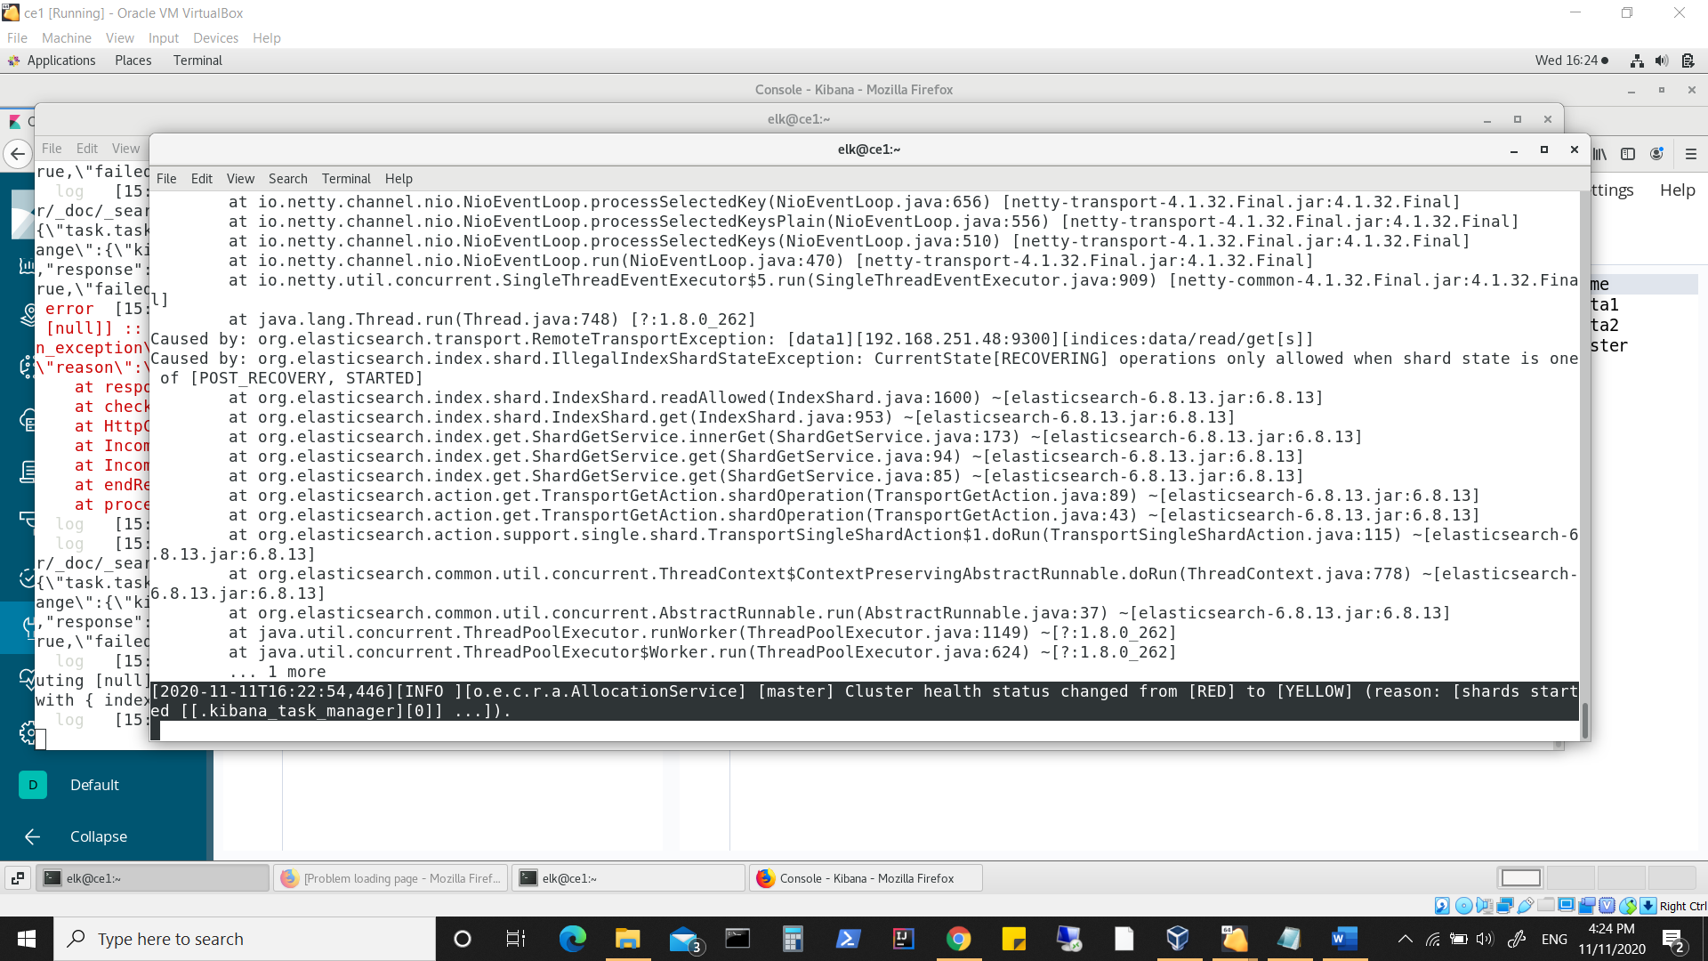

**Node2 -- starting**

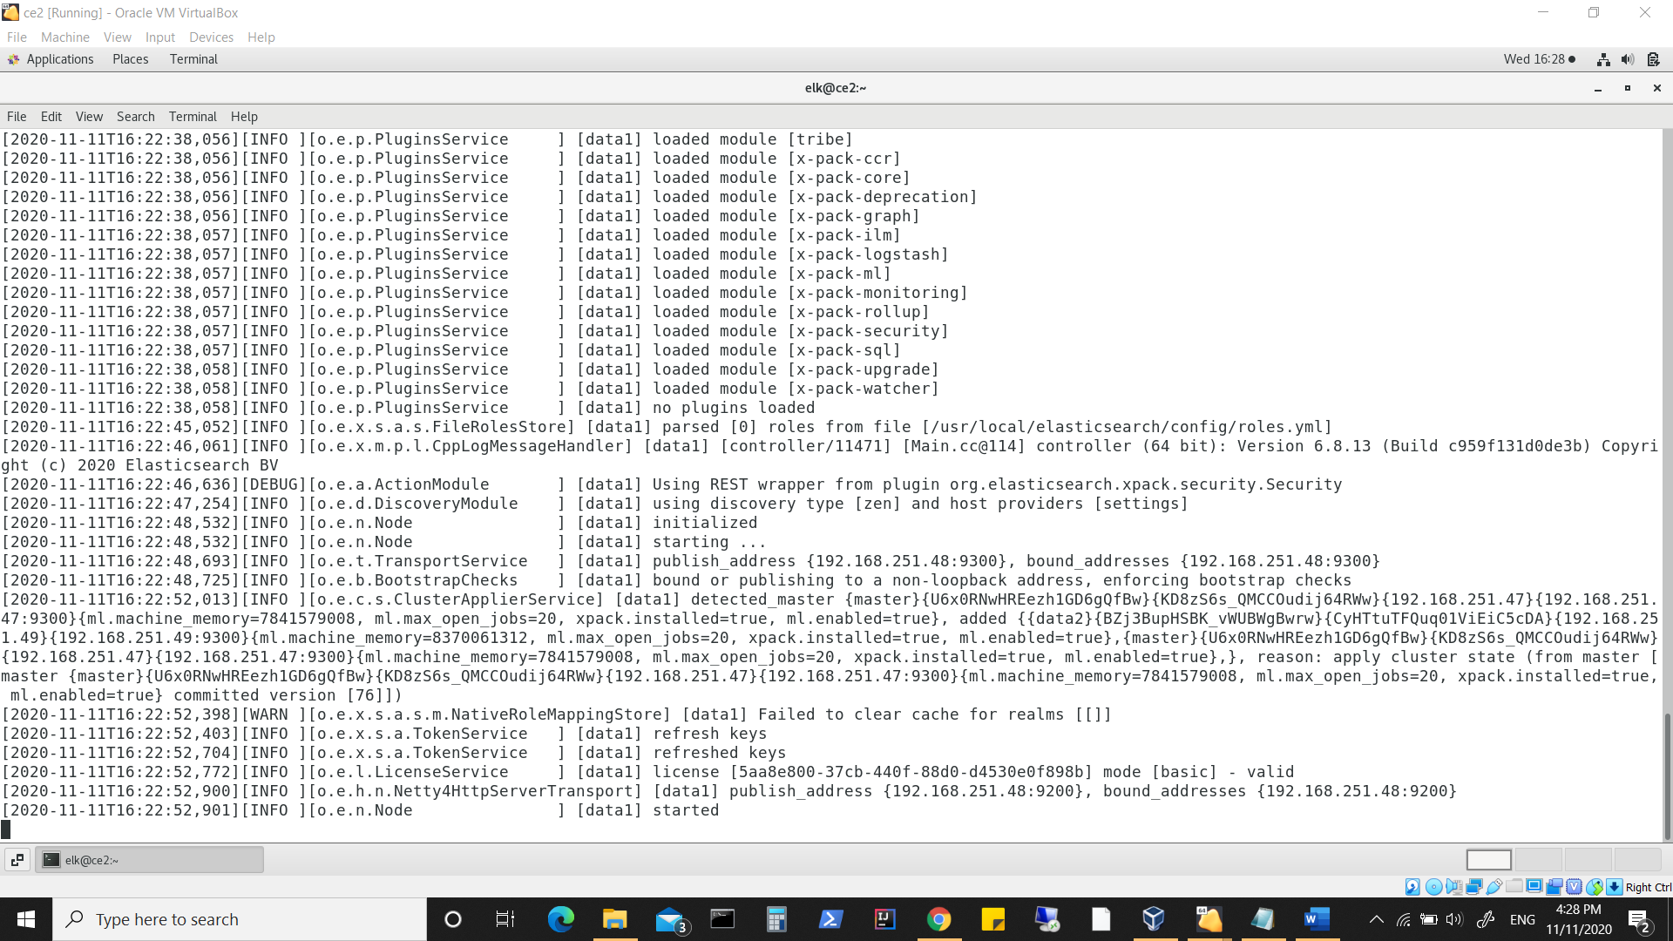

**Keep a watch on committed version in above screenshot.**

**Node3 -- starting**

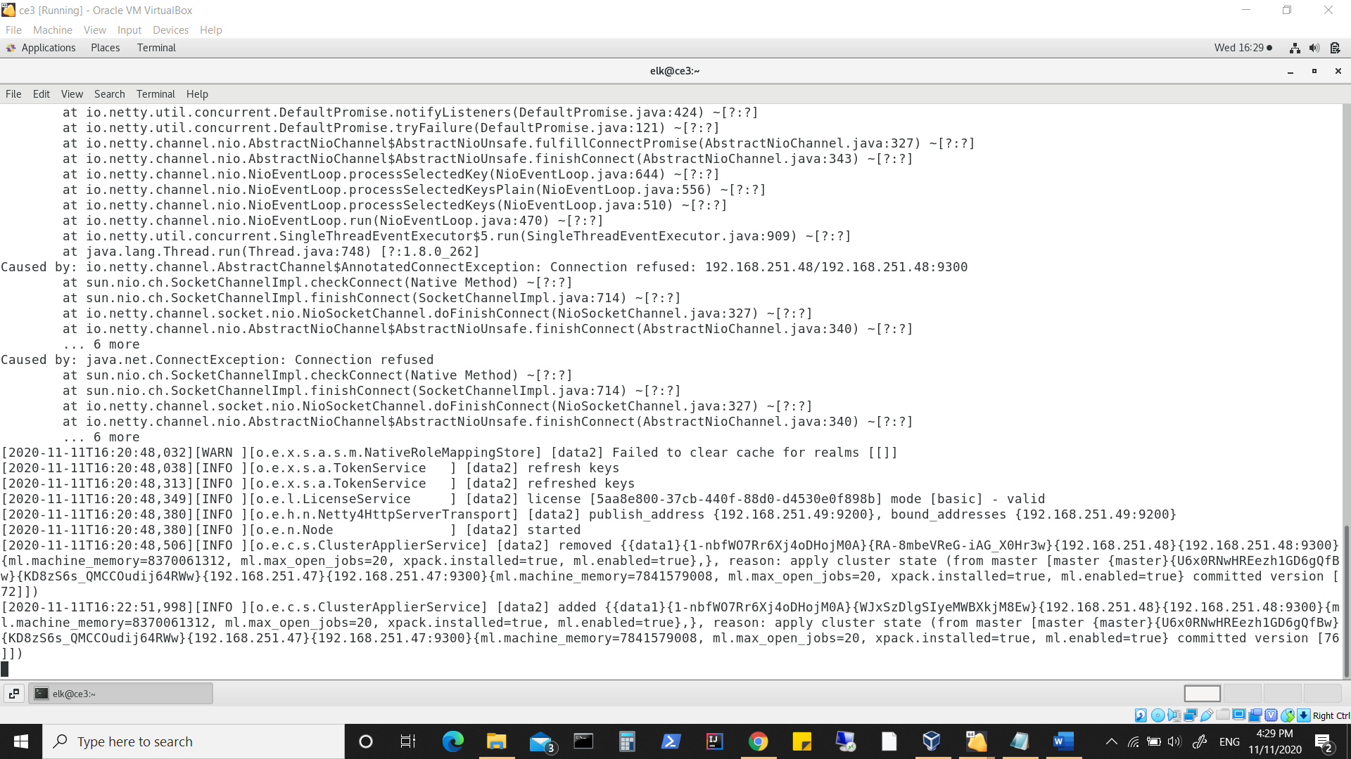

**Keep a watch on committed version in above screenshot.**

**Staring Kibana on Node1**

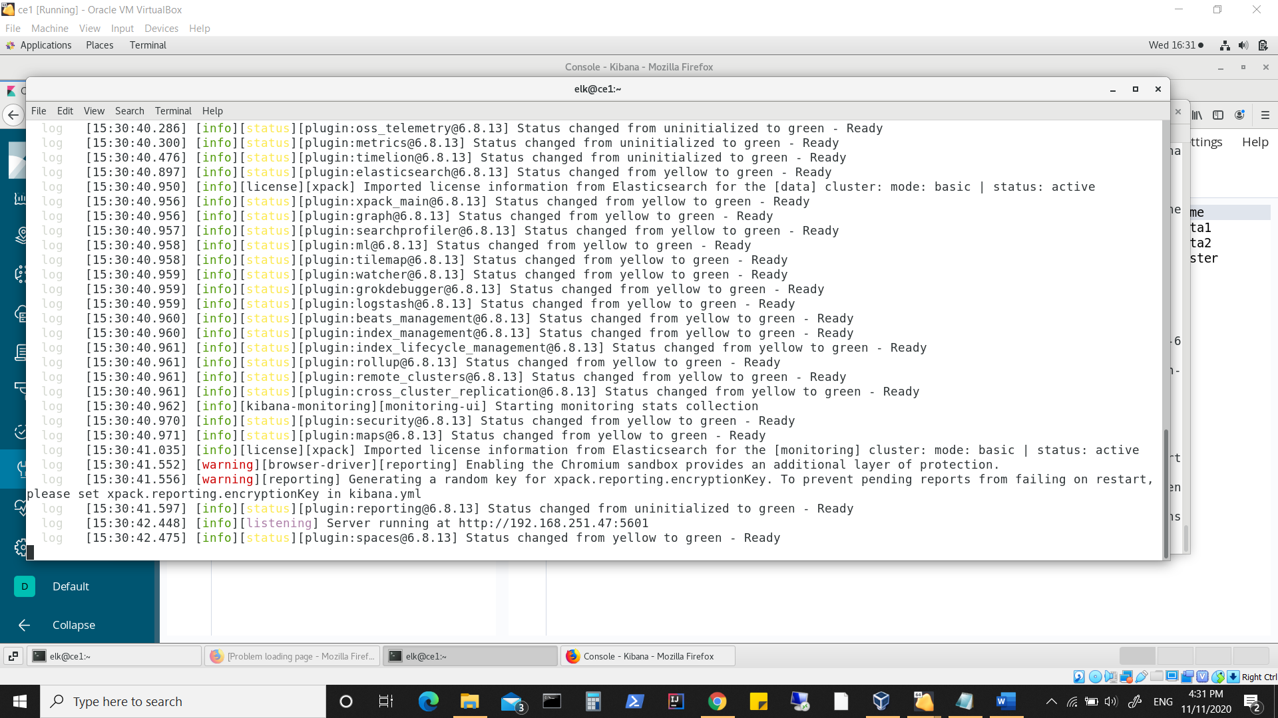

**Checking status in Kibana**

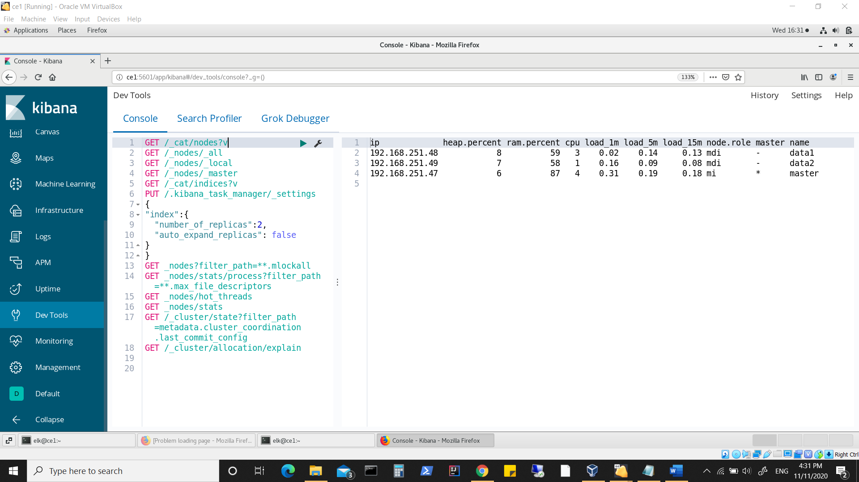

**Creating an index**

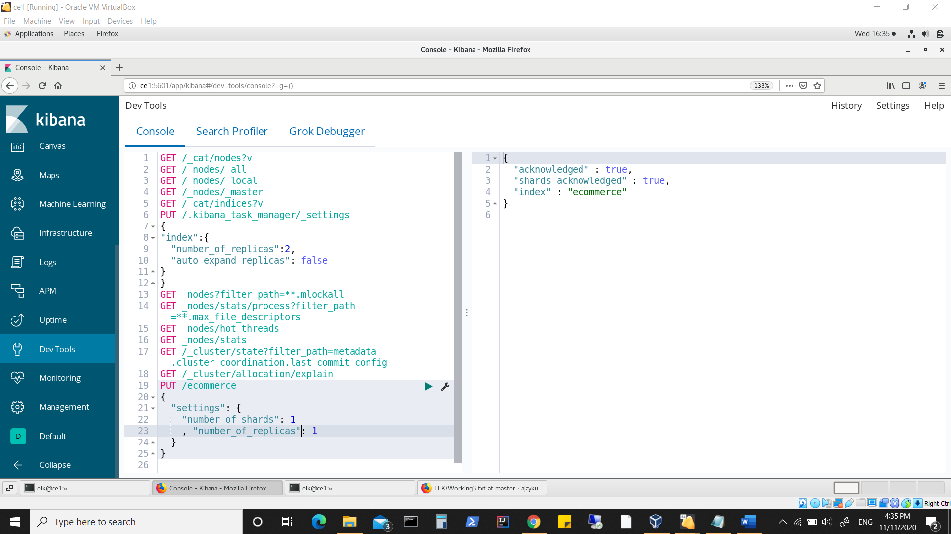

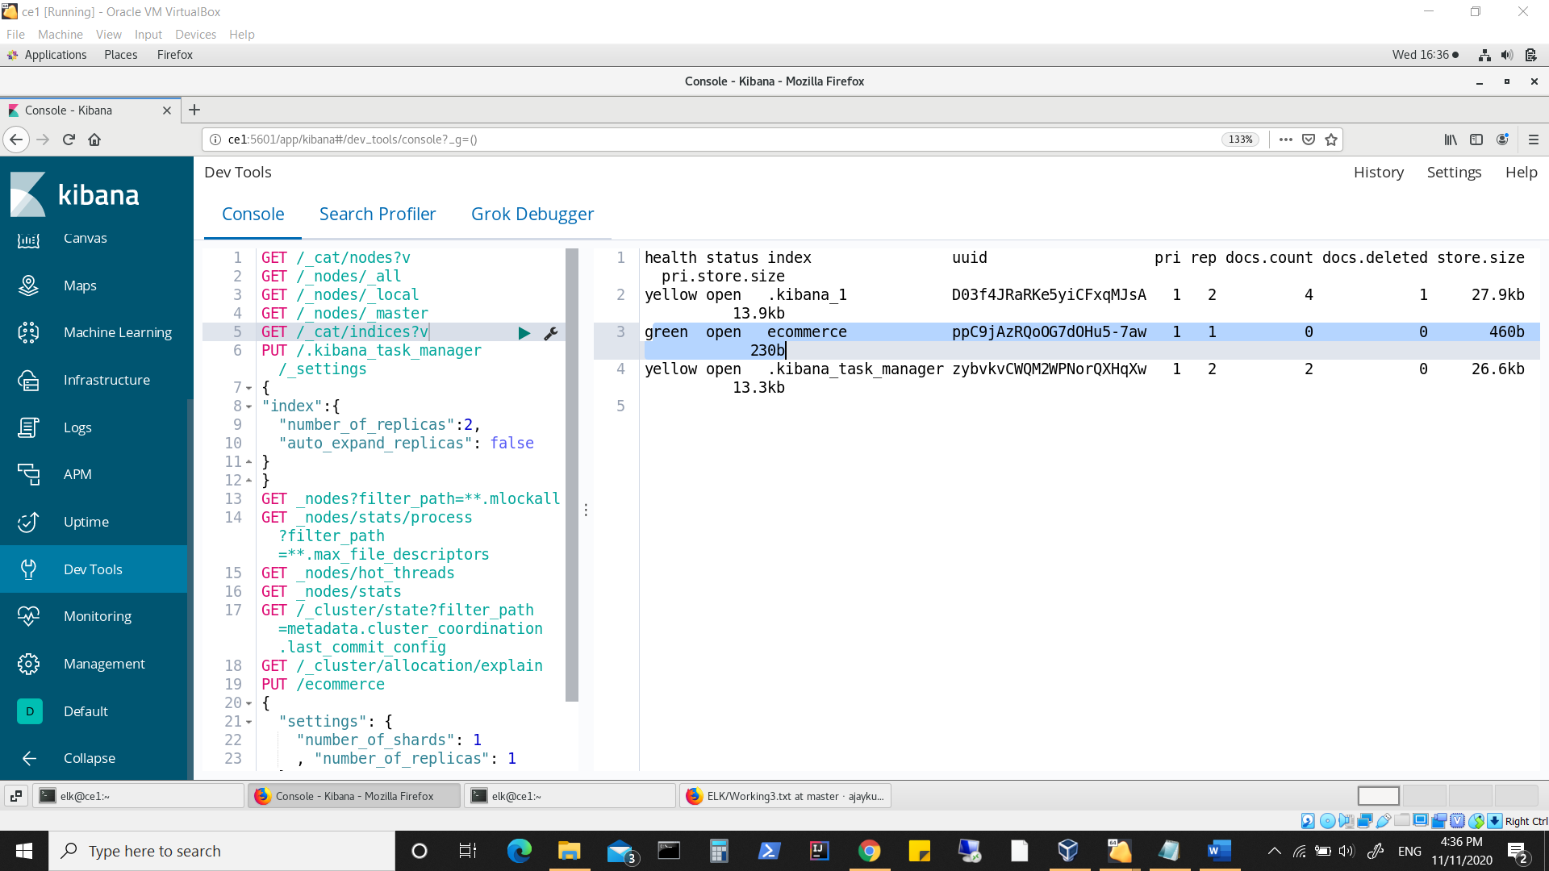

**Added some data**

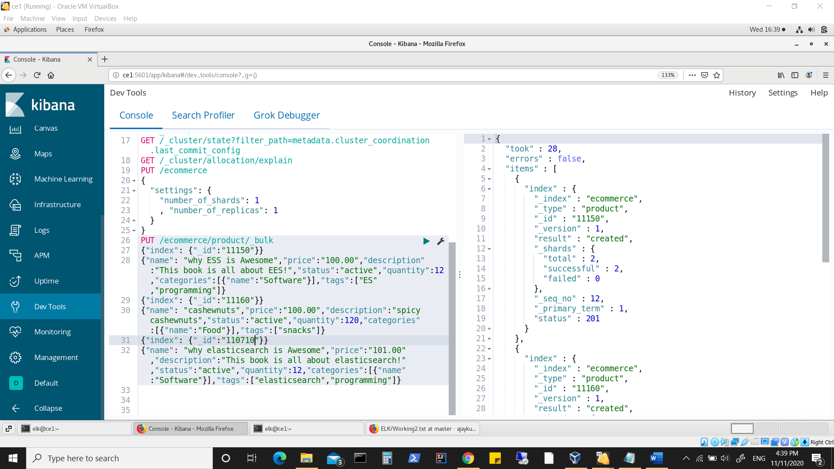

**Status of index**

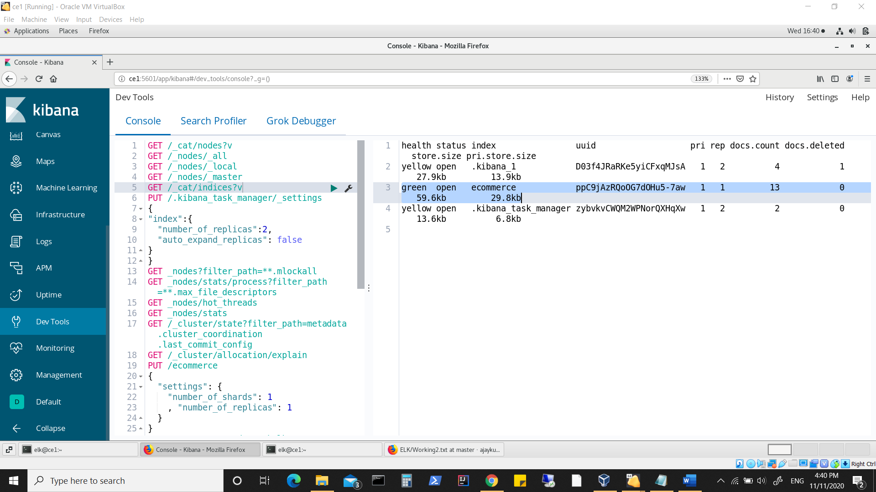

**Using /_cluster/allocation/explain**

**Note below where it shows about two indexes which could not have their shards assigned as set replication is 3 and at this point of time we have only two available data nodes (Node2, Node3), plus one of the data node was restarted in between.**

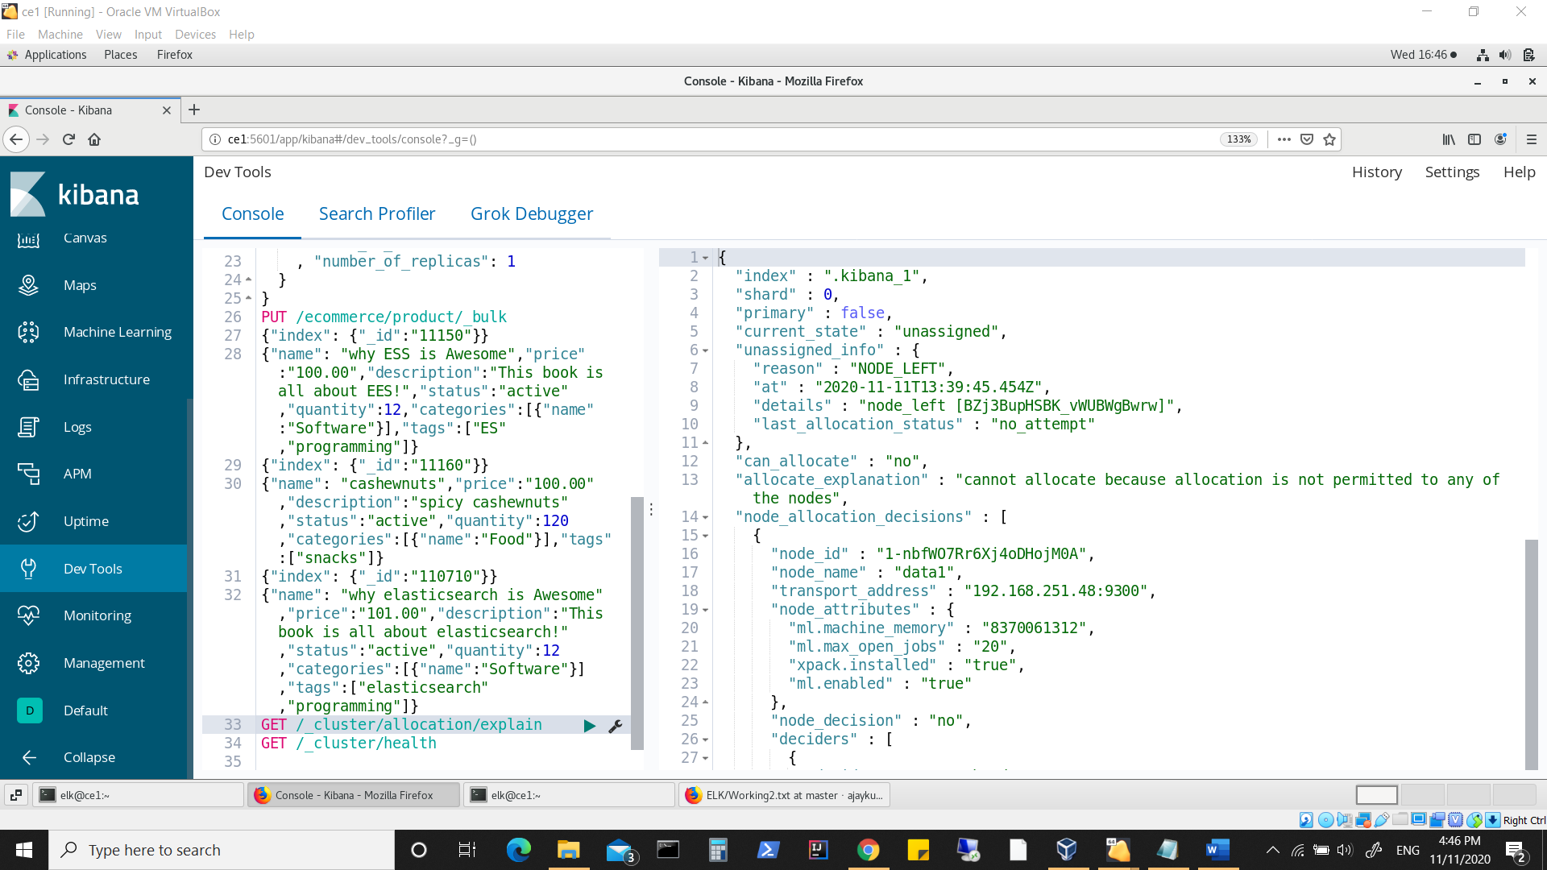

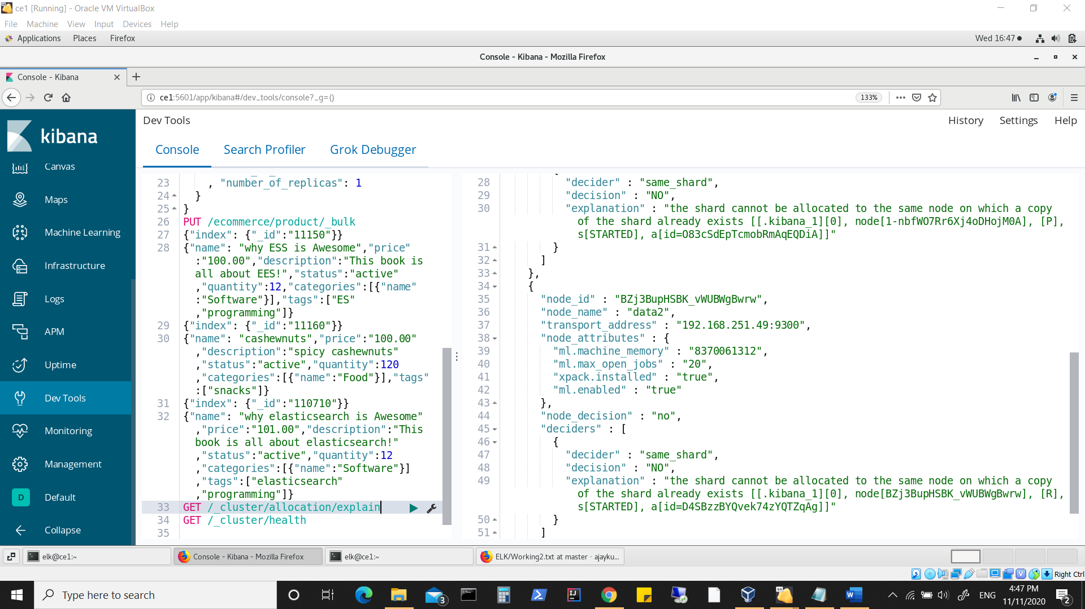

**Using /_cluster/health**

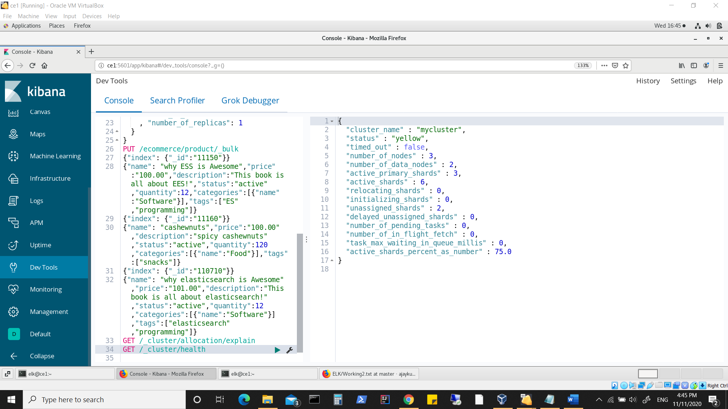

**Viewing cluster health on a shard level per index**

**Ecommerce index was defined with number of shards=1, number of replicas=1, which means this index will have its data in one shard, and with one replica. ( thus 1 primary and 1 replica)**

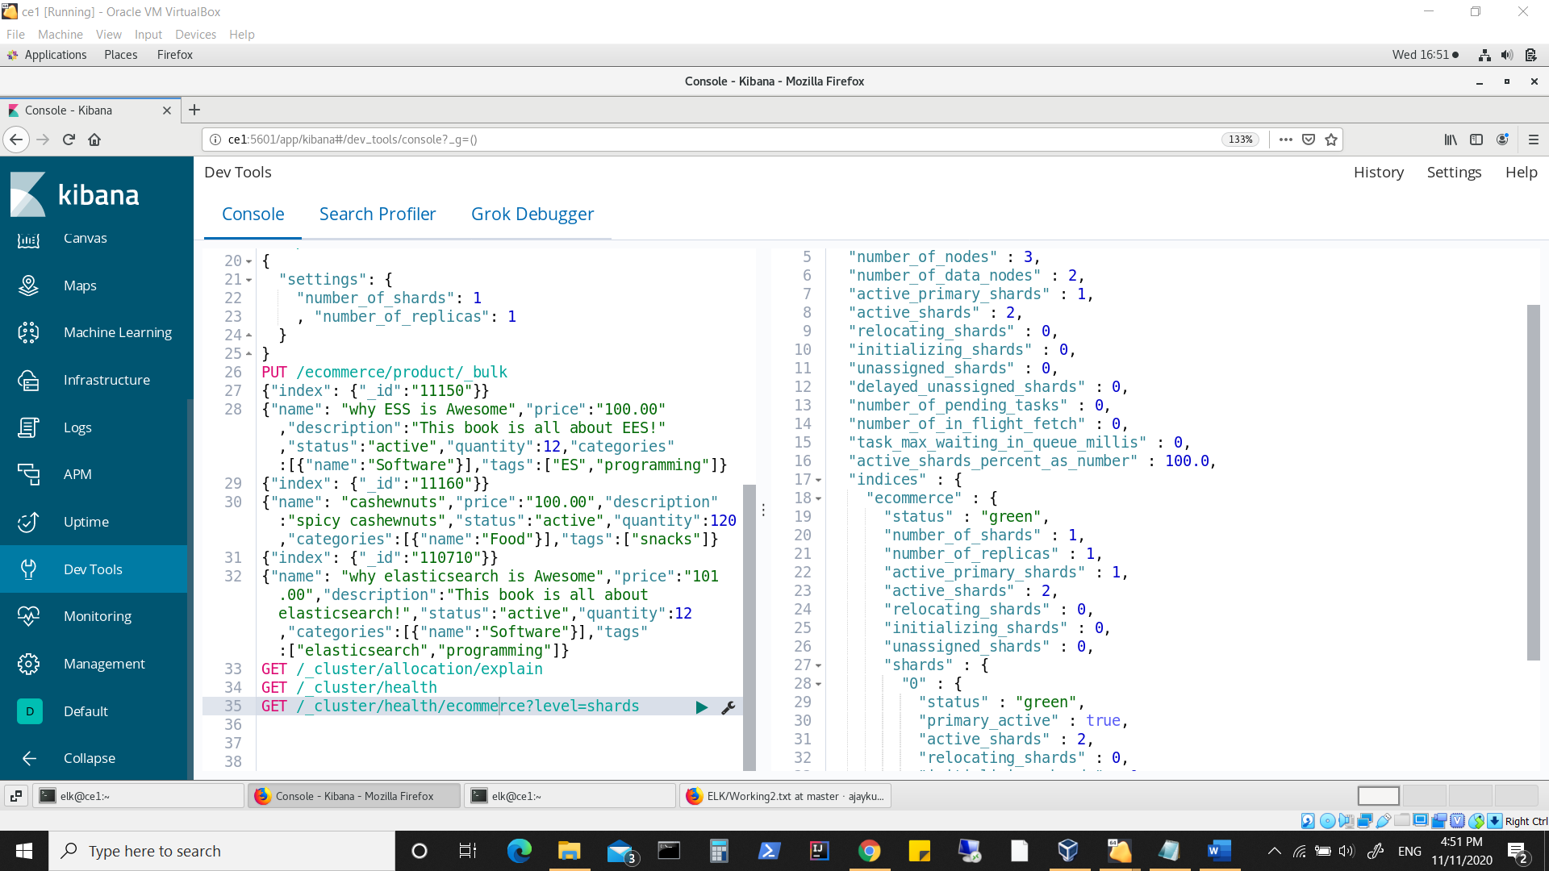

**Looking at shards distribution**

**Notice primary shard is on node3, replica shard is on node2**

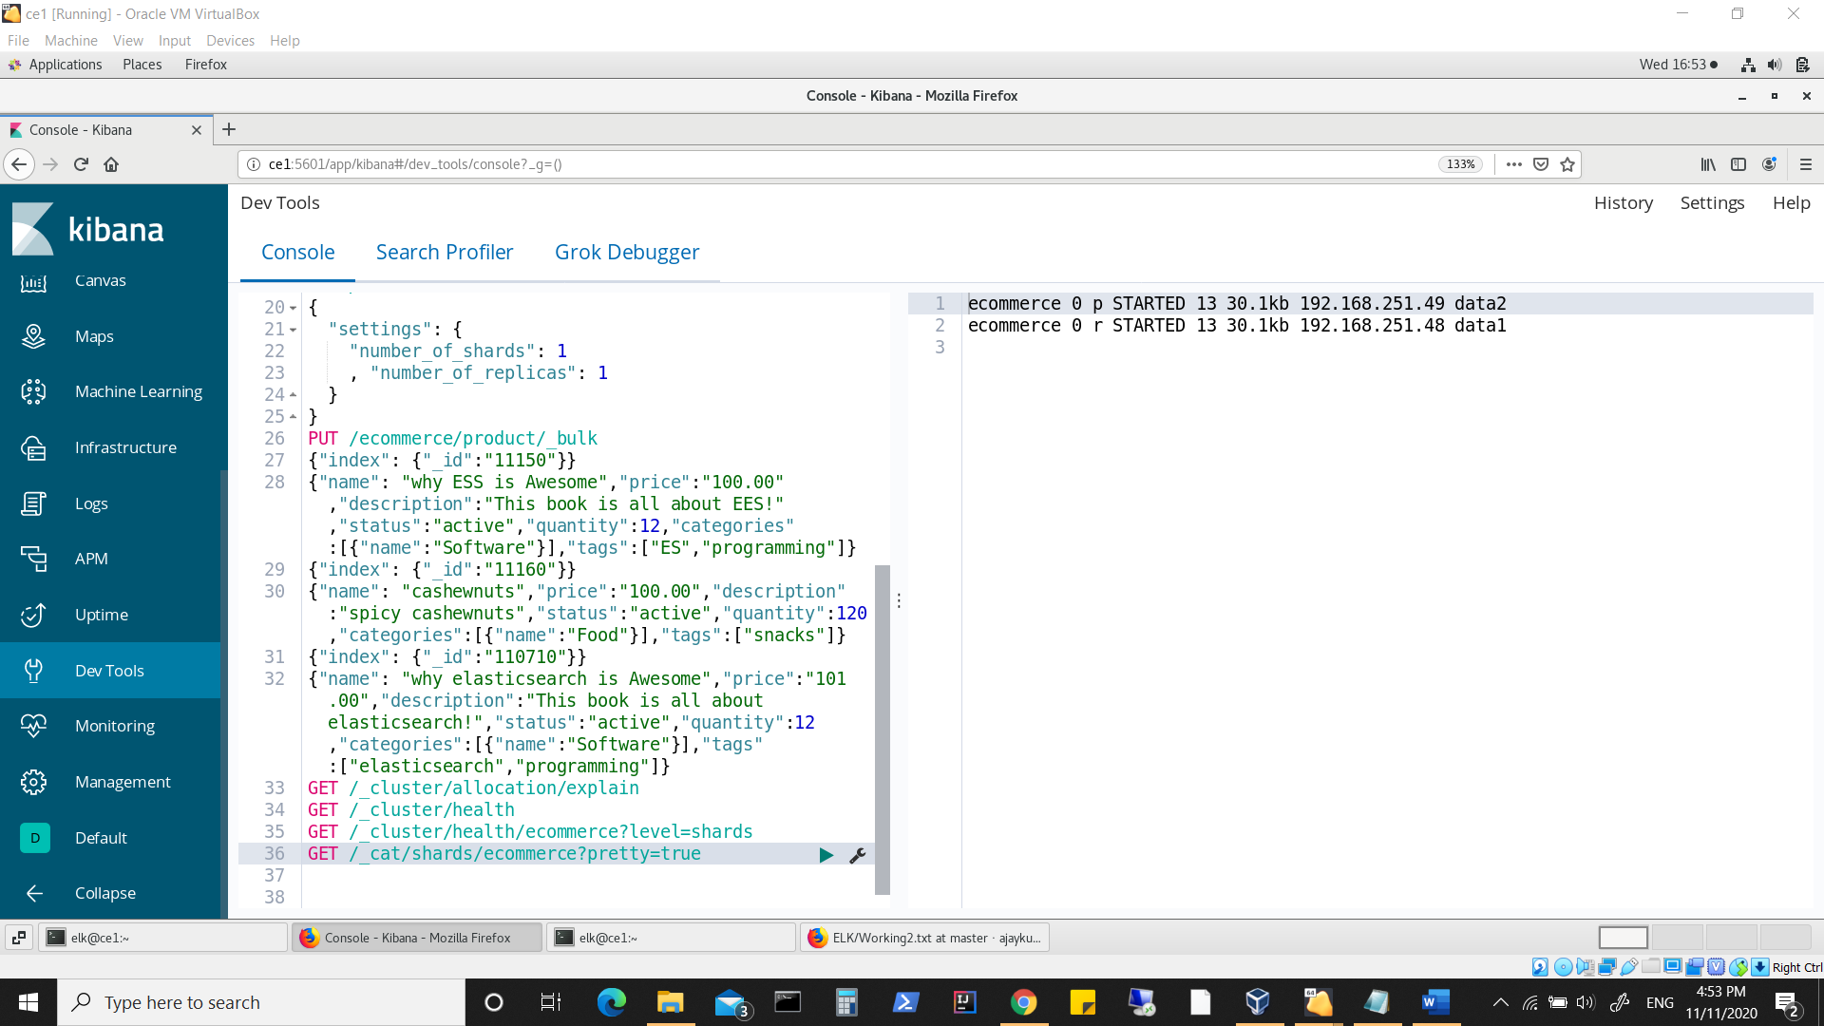

**Similarly, we can check for other indexes also**

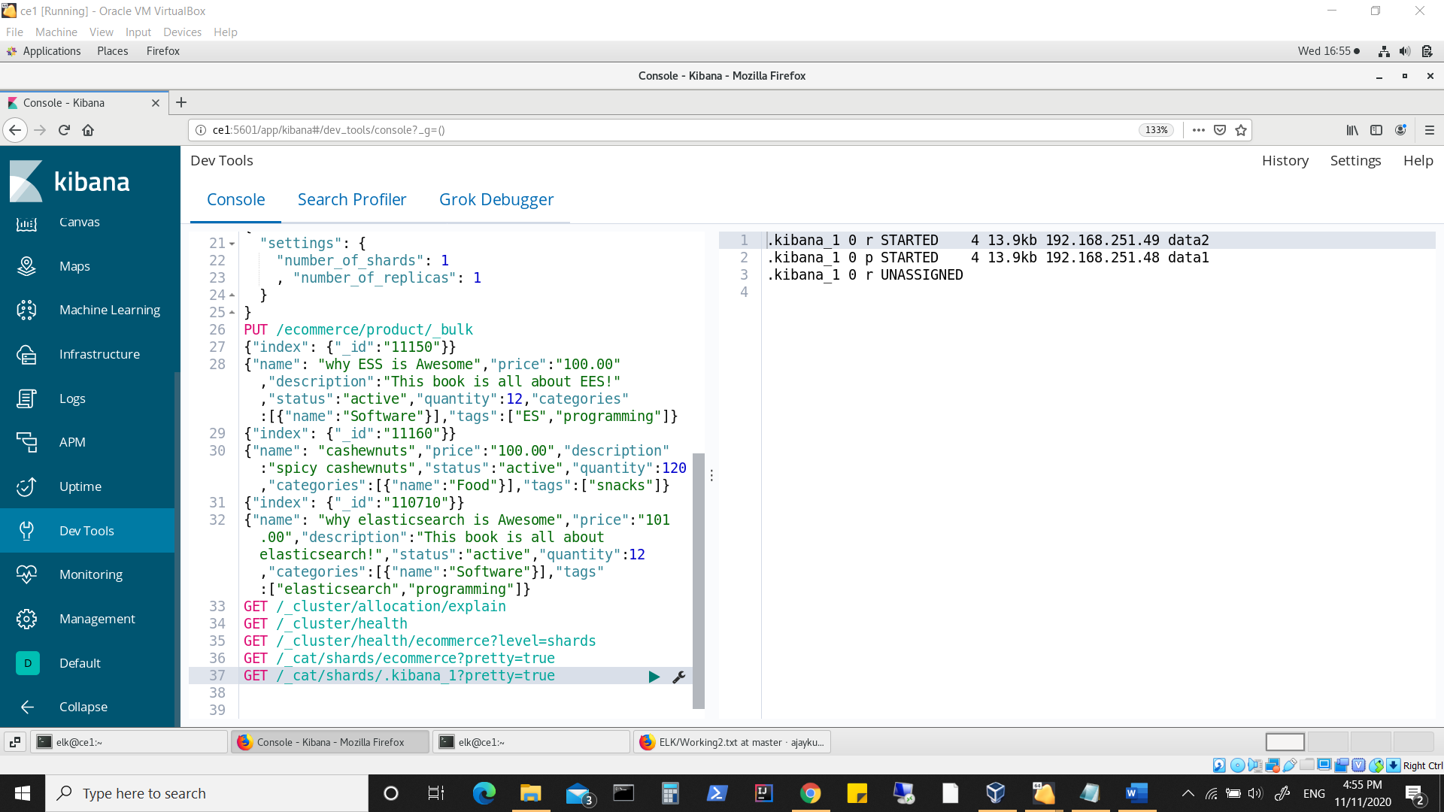

**Changed the replication of ecommerce index and checking shard status**

**Since we have only 2 datanodes, increasing replica to 2 results in 1 replica being unassigned.**

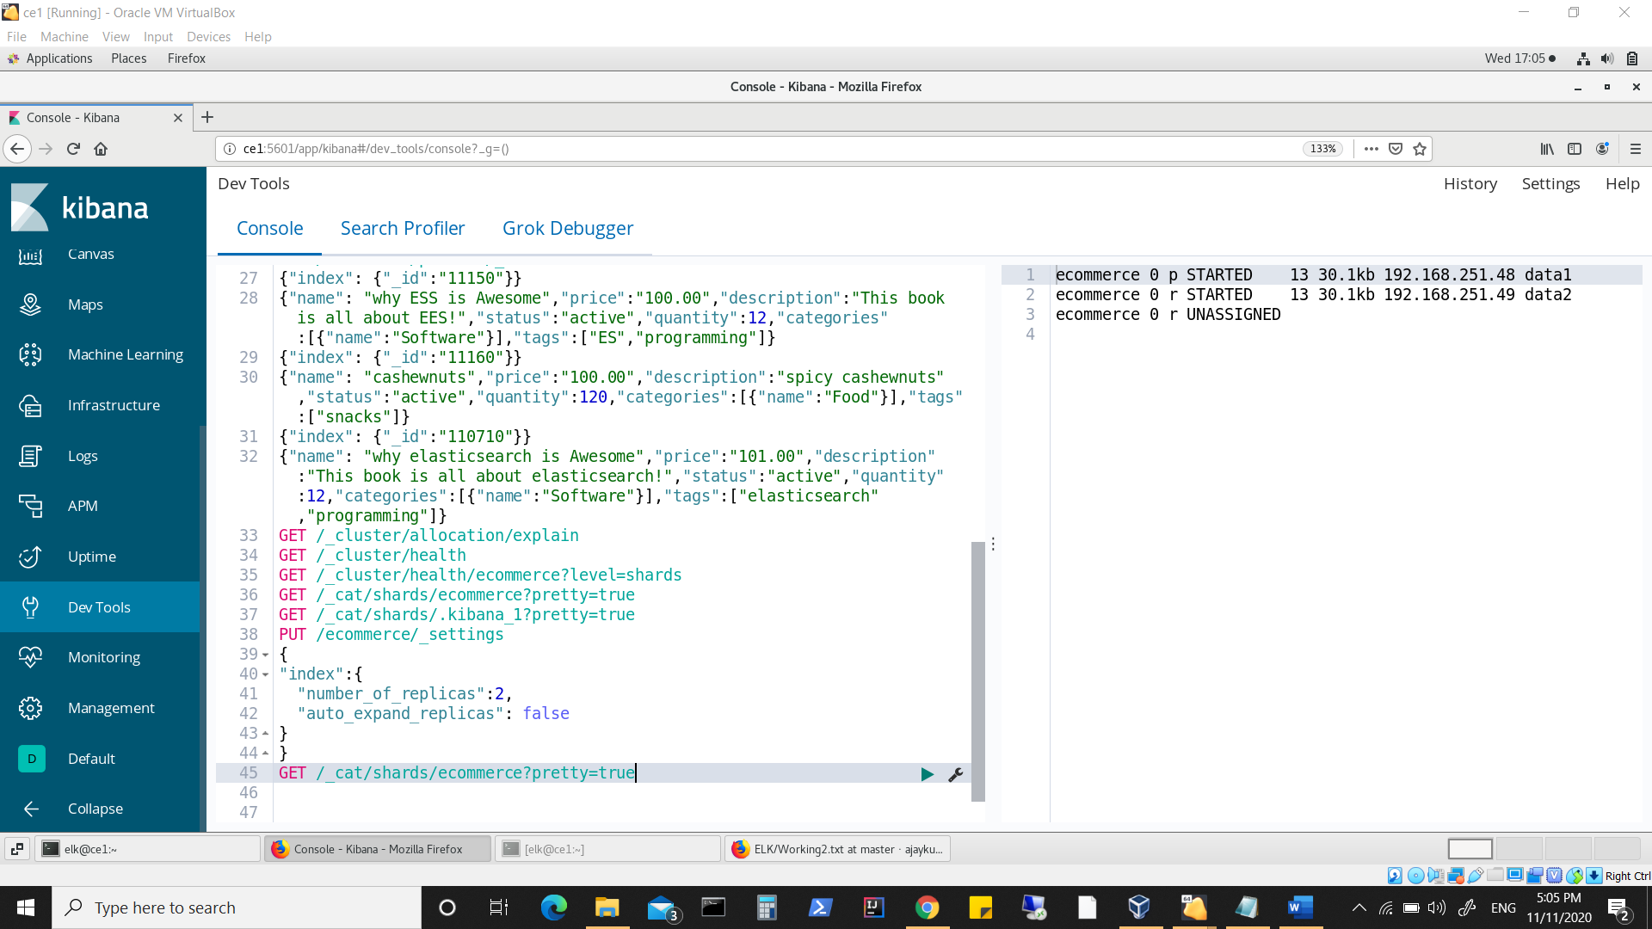

**Note as of now we have 1 master node(node1), 2 data nodes (node1, node2) and all are master eligible.**

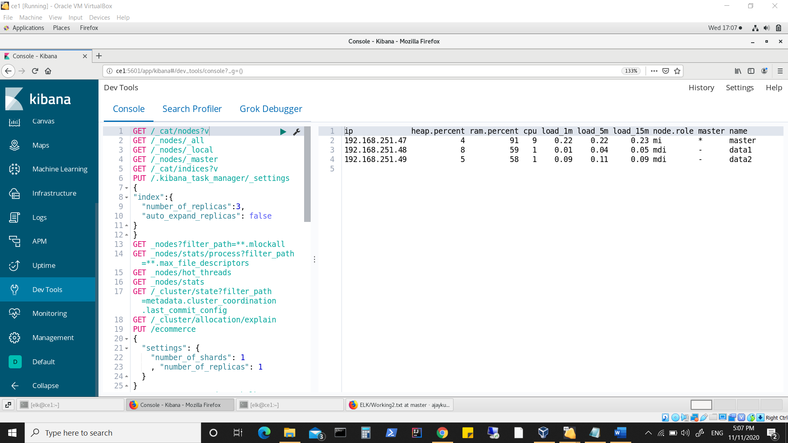

**Looking in log of master node (node1)**

**Look at committed version which is changed.**

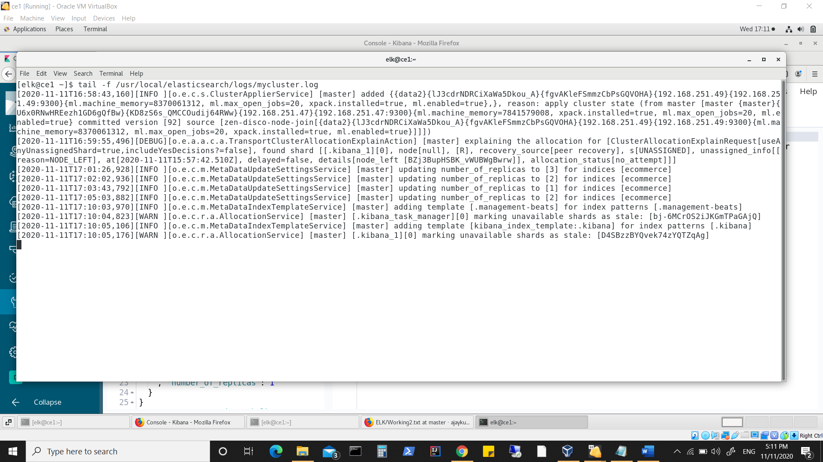

**Checking status of replicas again for ecommerce index**

**Looking into log of 2nd node(node2)**

**Look at committed version which is changed.**

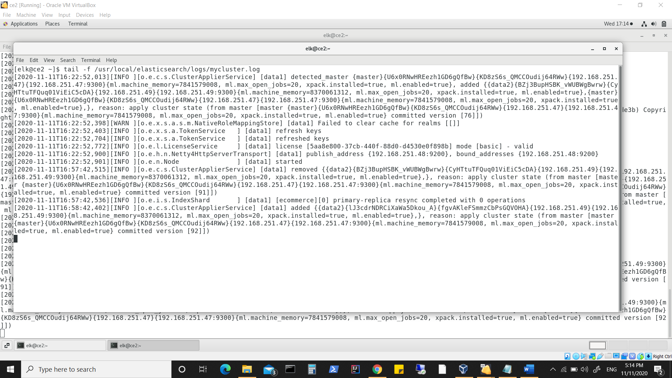

**Log form 3rd node**

**Look at committed version which is changed.**

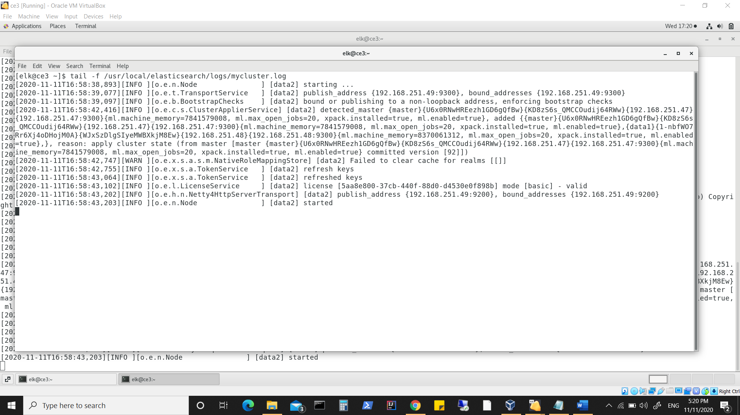

**After shutting down master(node1), node2 is elected as master**

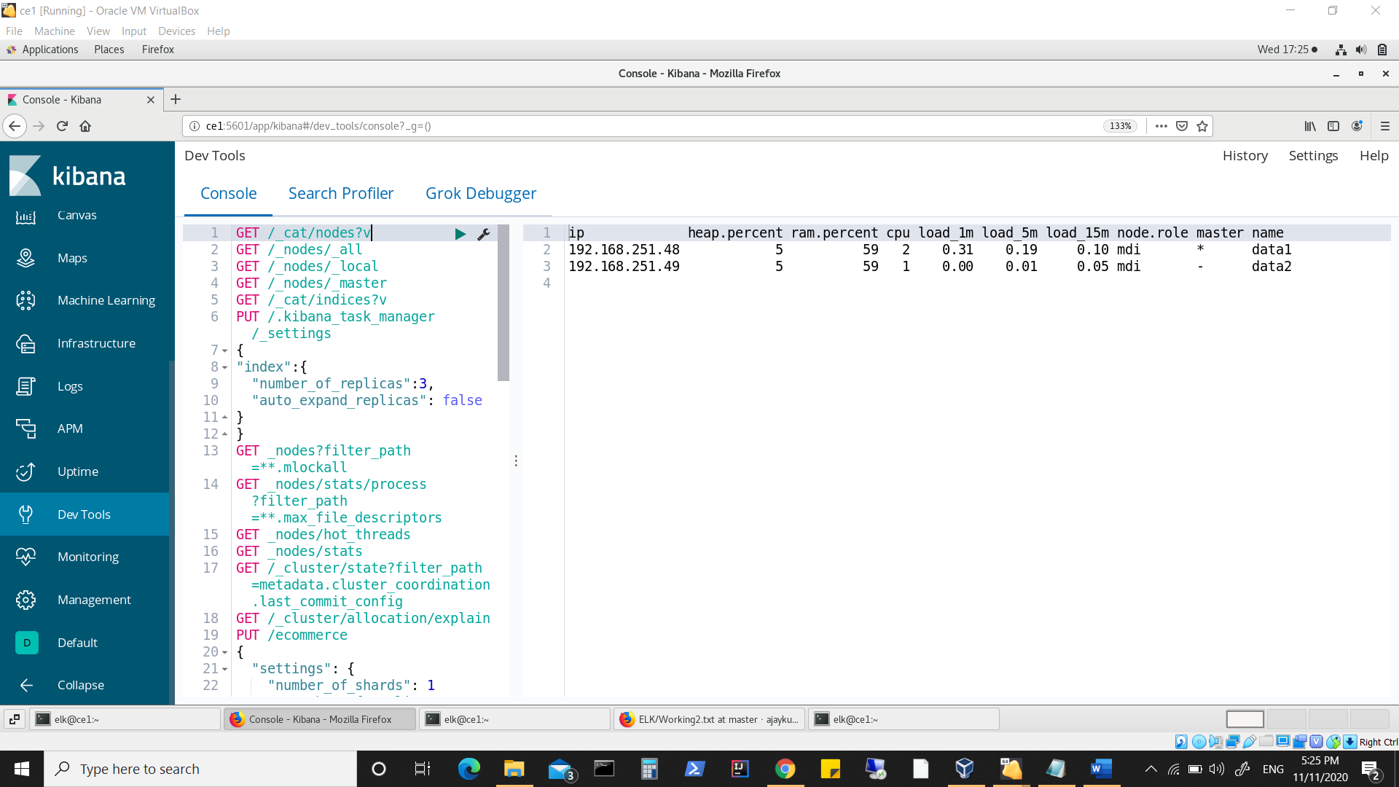

**Primary shard and replica shard status remains same as we still have 2 datanodes.**

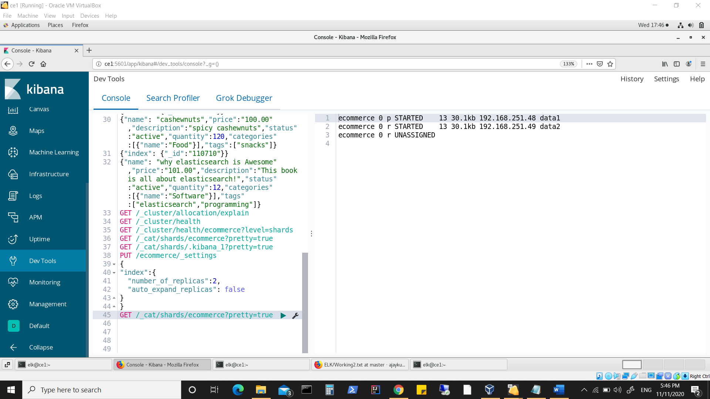

**Restarted master (also made it data.node:true)**

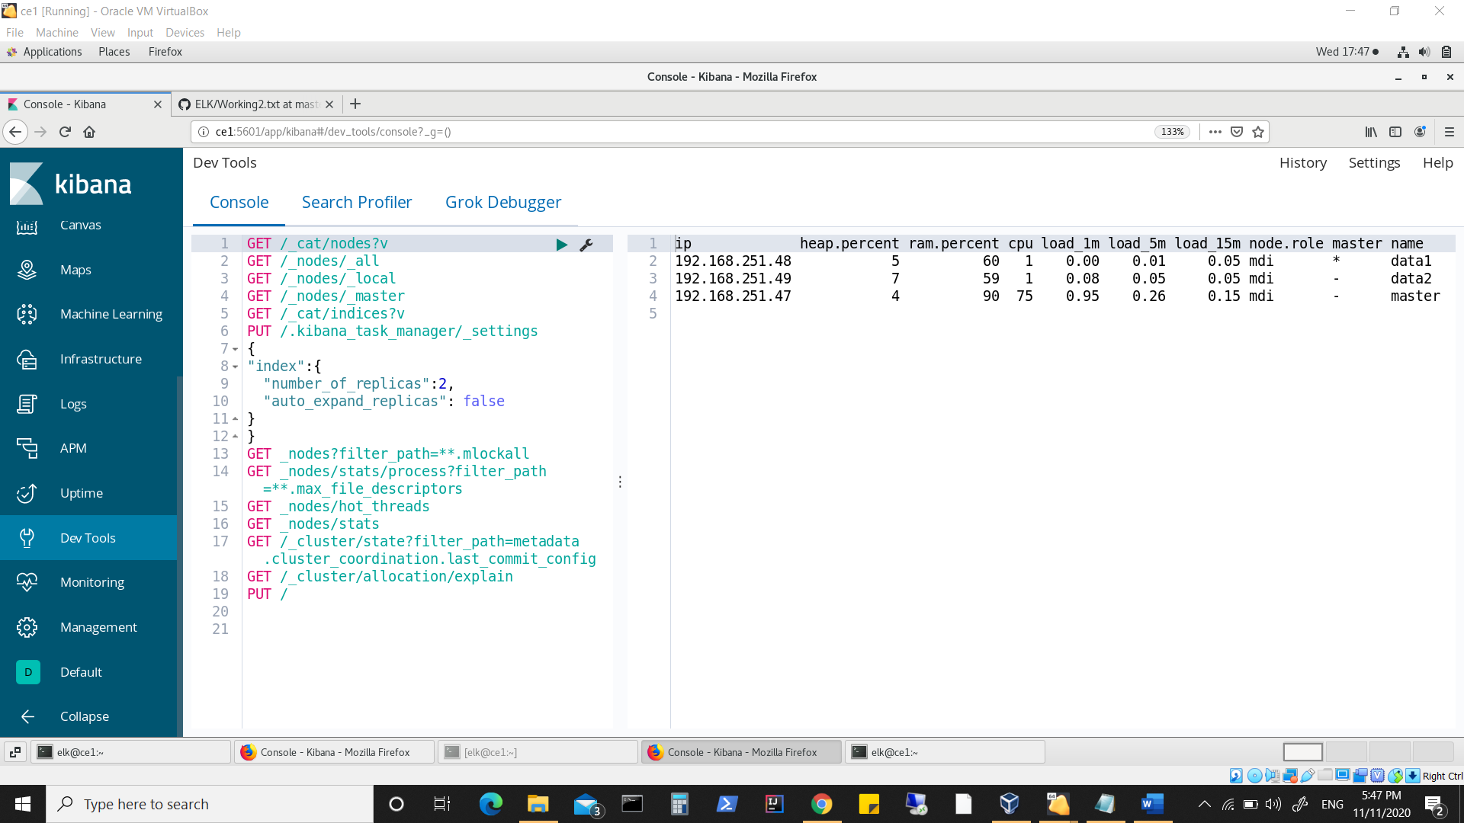

**Now the unassigned replica is assigned**

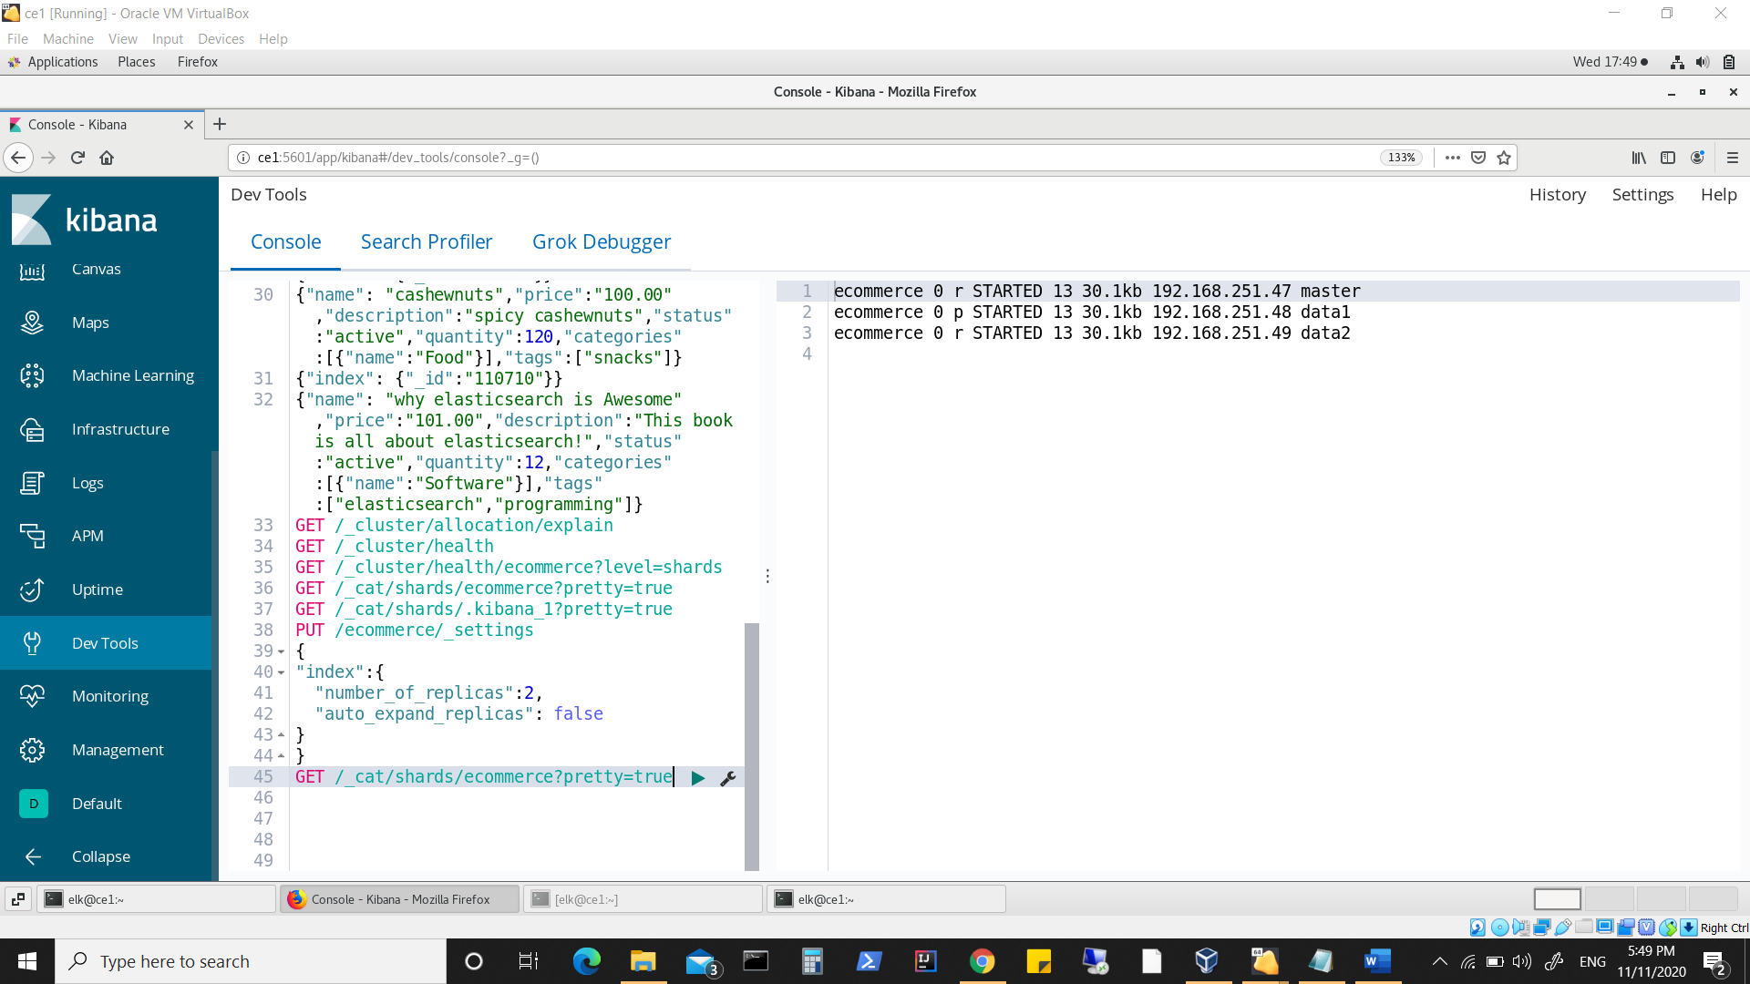

**Similarly**

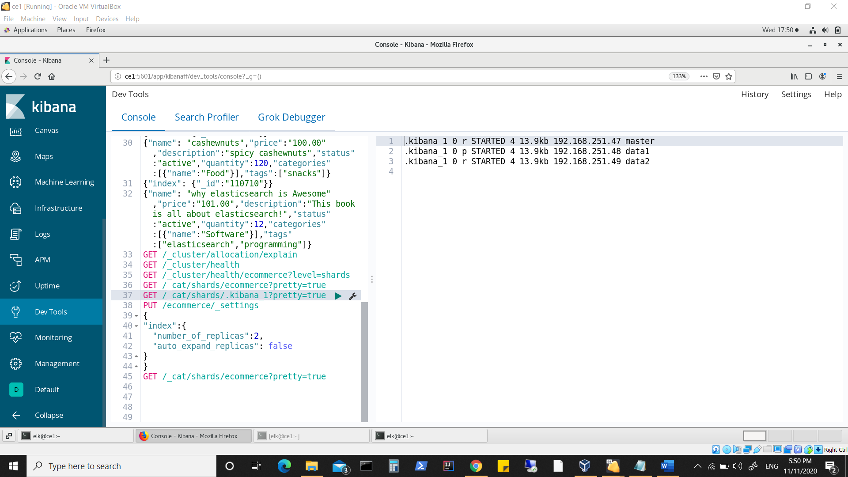

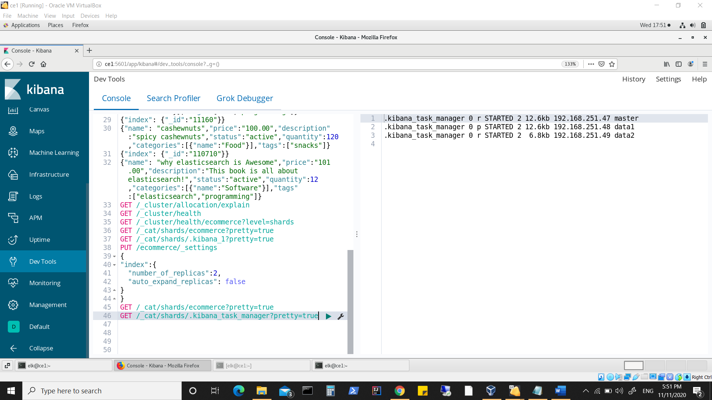

**Looking into logs again**

**Master ie node 1 log**

**Keep a watch on committed version which shows an increase and change.**

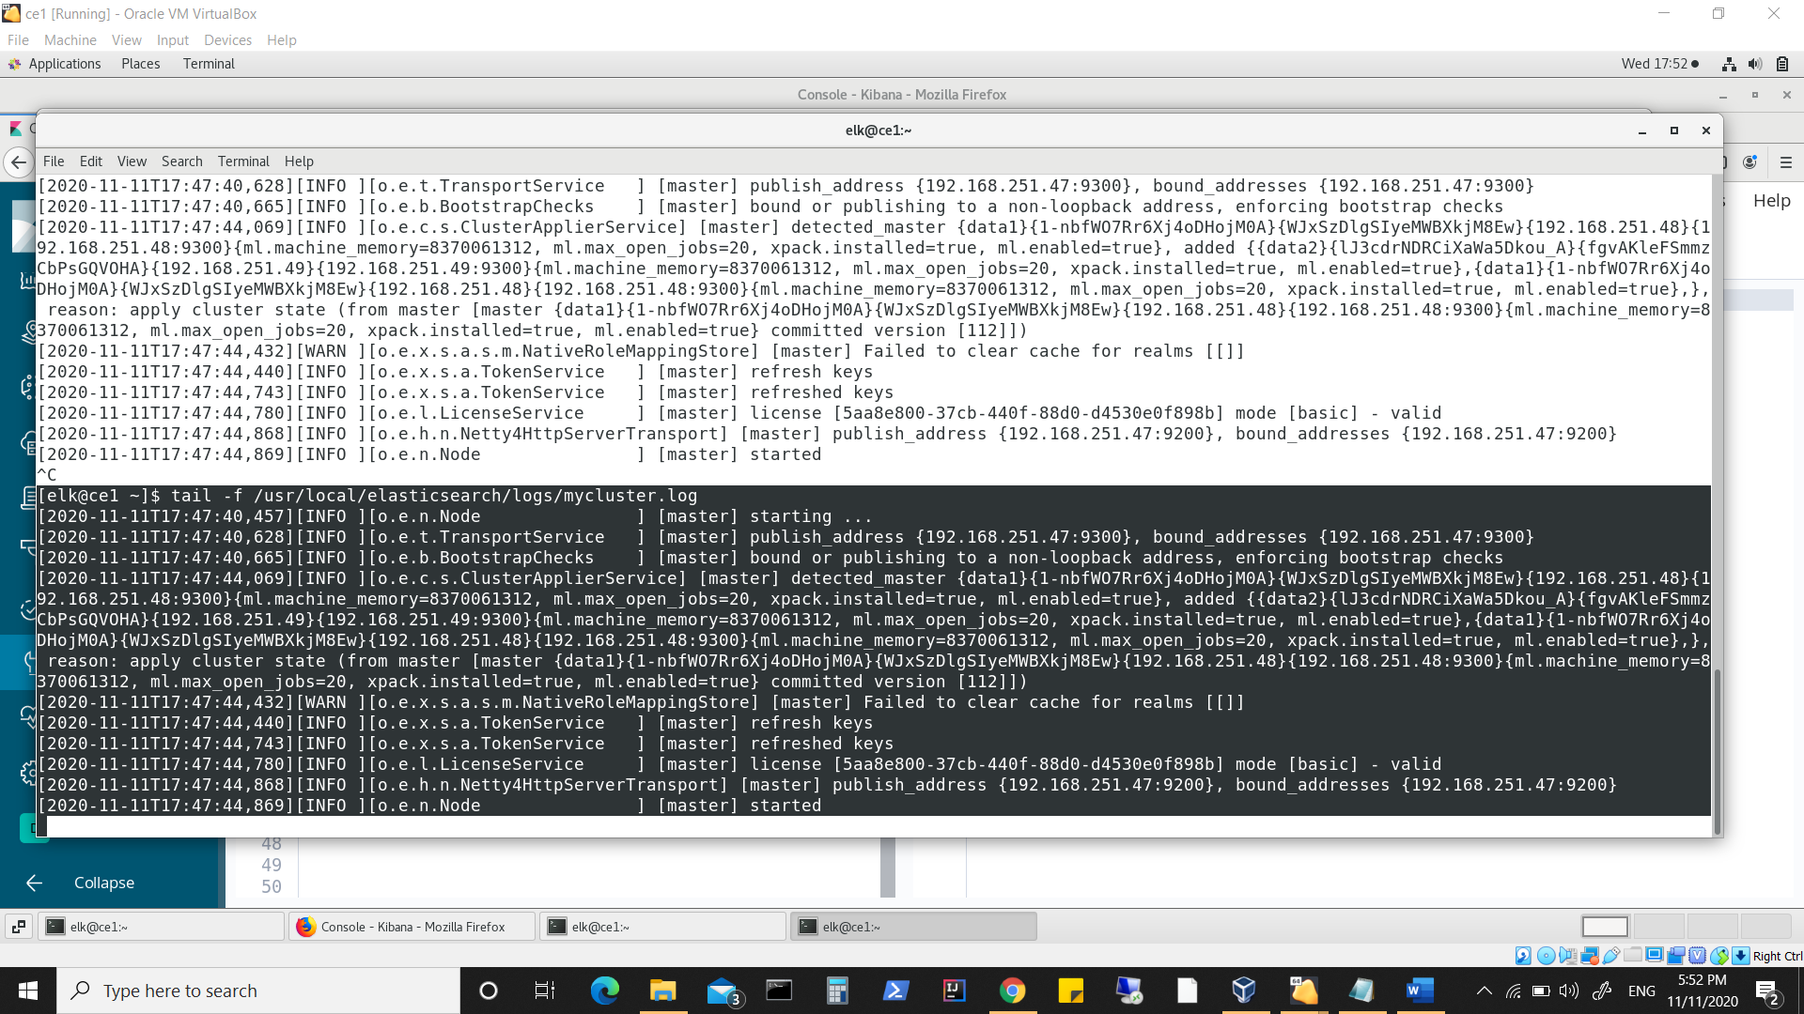

**Data1 ie Log from node 2**

**Keep a watch on committed version which shows an increase and change although this node was touched, nor any update was made to index.**

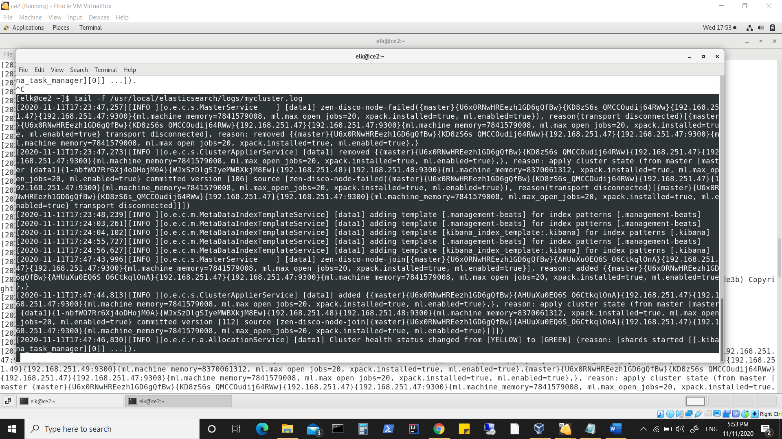

**Data2 ie log from node3**

**Keep a watch on committed version which shows an increase and change although this node was touched, nor any update was made to index.**

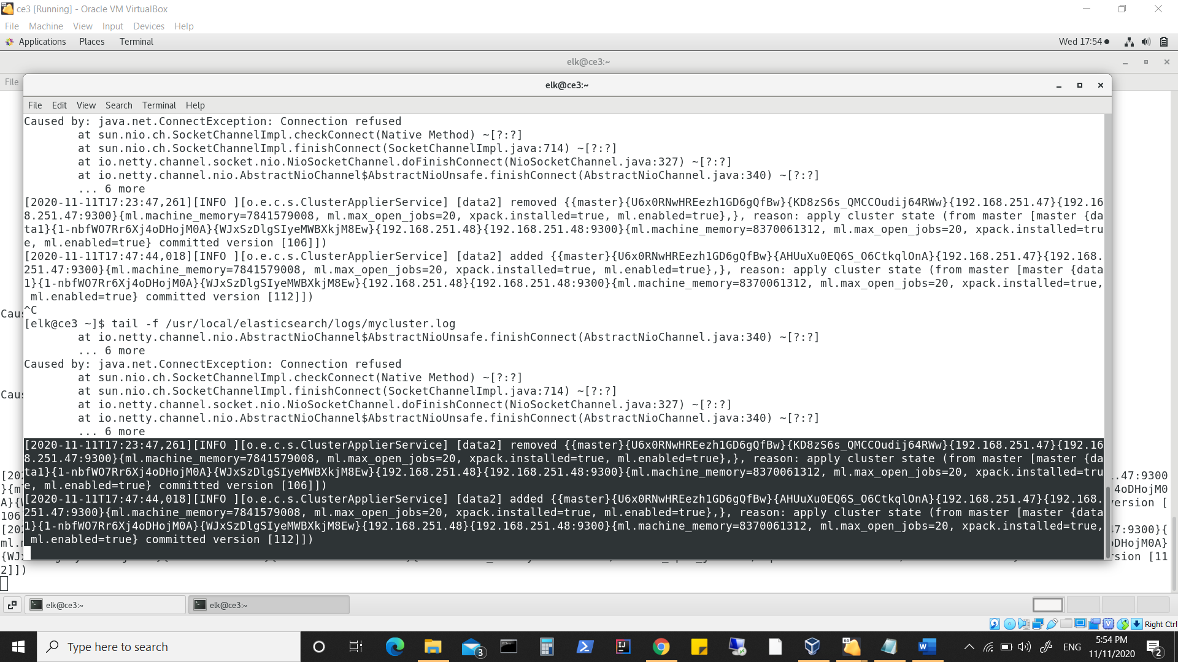

**Now shutting down data1 which has primary shards of all 3 indexes**

**Now node1 has become the master**

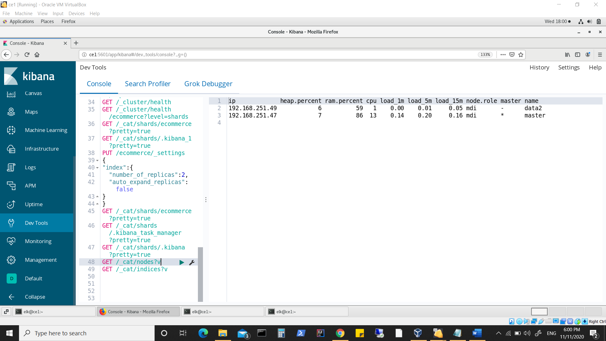

**We can see the primary shard is now on node1(master)**

**Which was recently made as datanode. Also one replica for each index remains unassigned.**

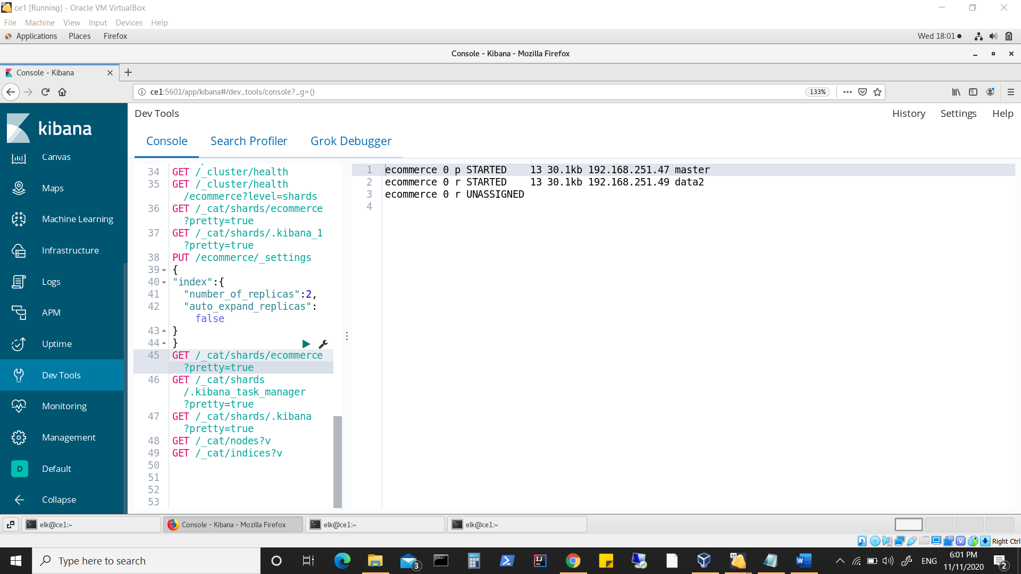

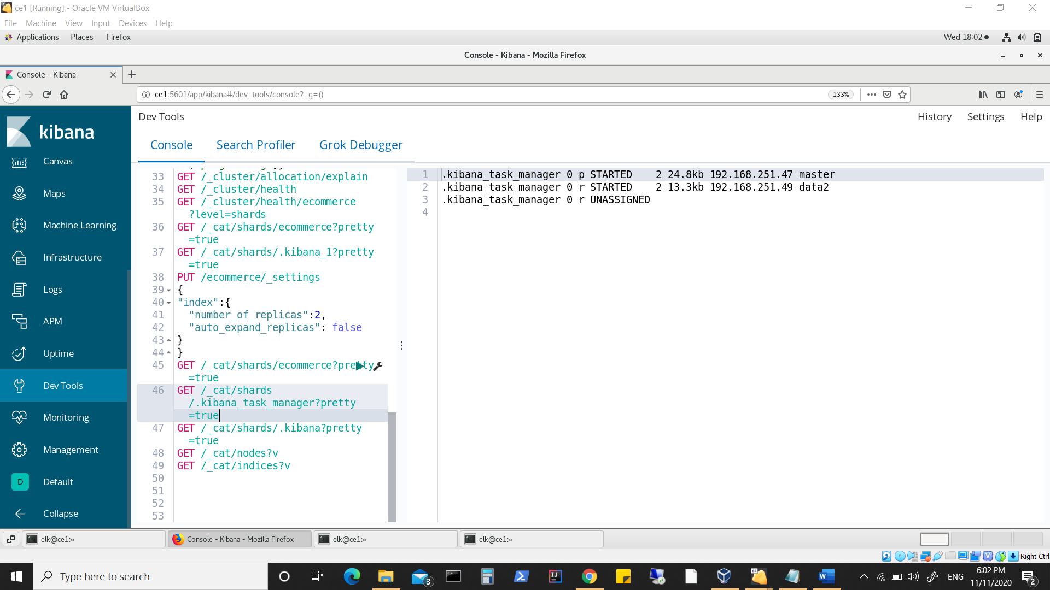

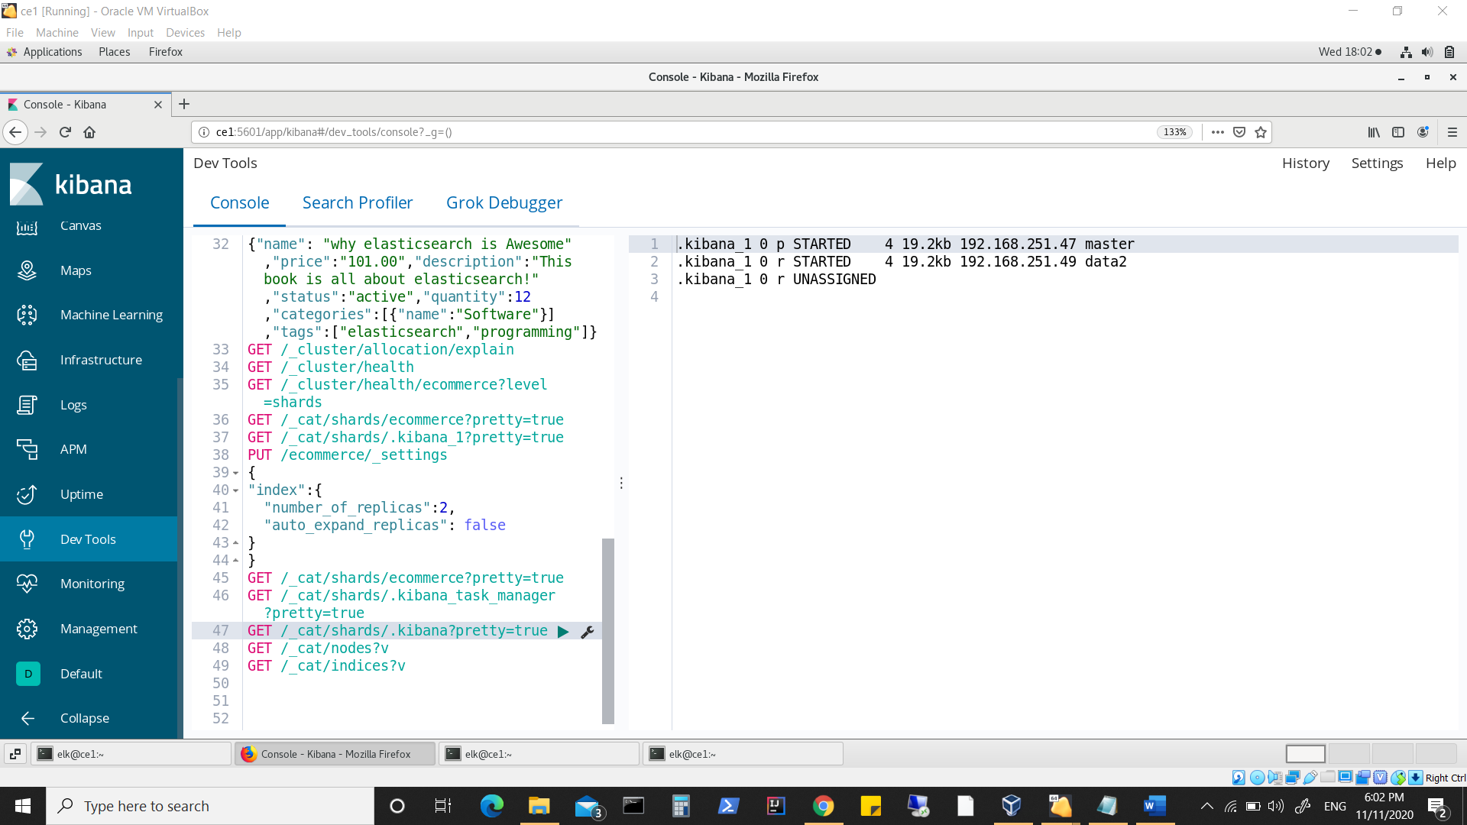

**Data1 (node2) was started again & unassigned shards are assigned.**

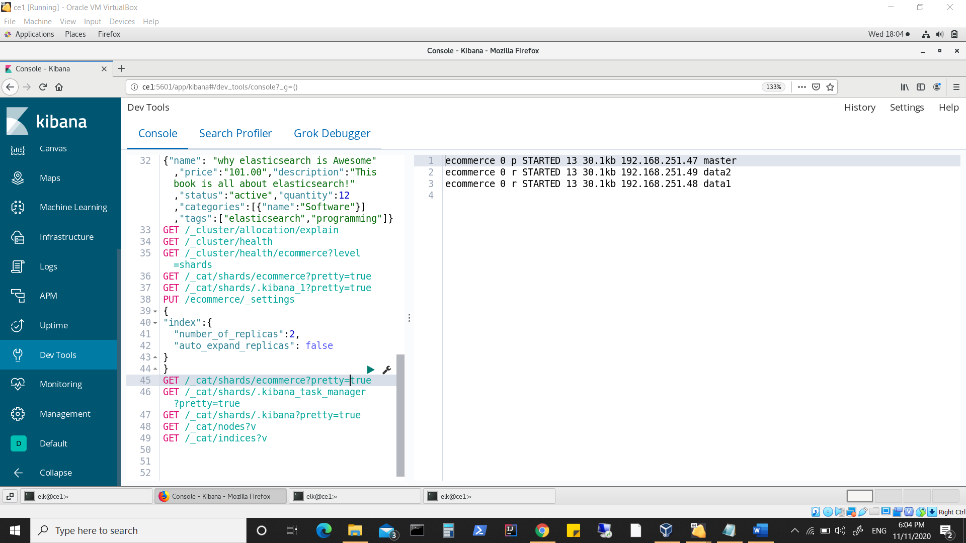

**Looking into node1(master) log**

**Also committed version is now 123.**

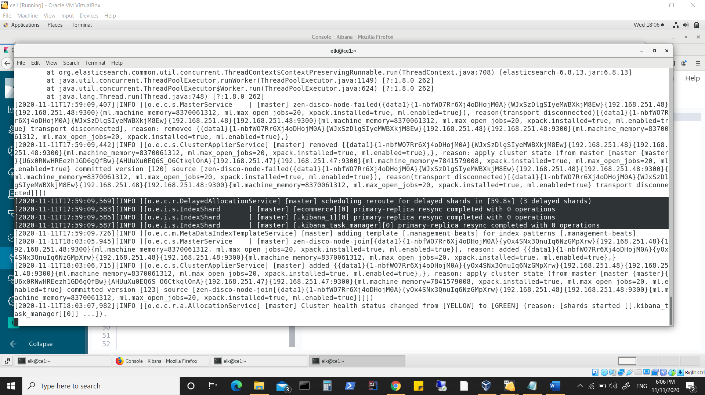

**Node2 log**

**Also committed version is now 123.**

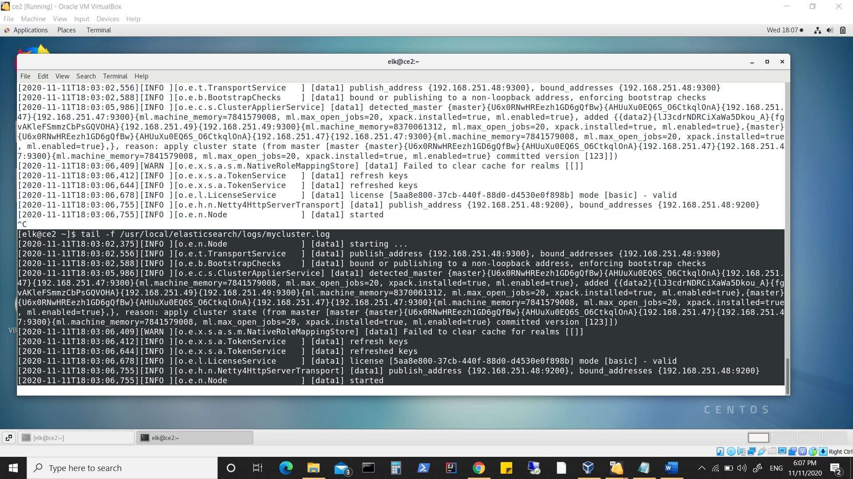

**Node3 log**

**Also committed version is now 123.**

**Look at other information such as global checkpoint, max_seq_no etc..**

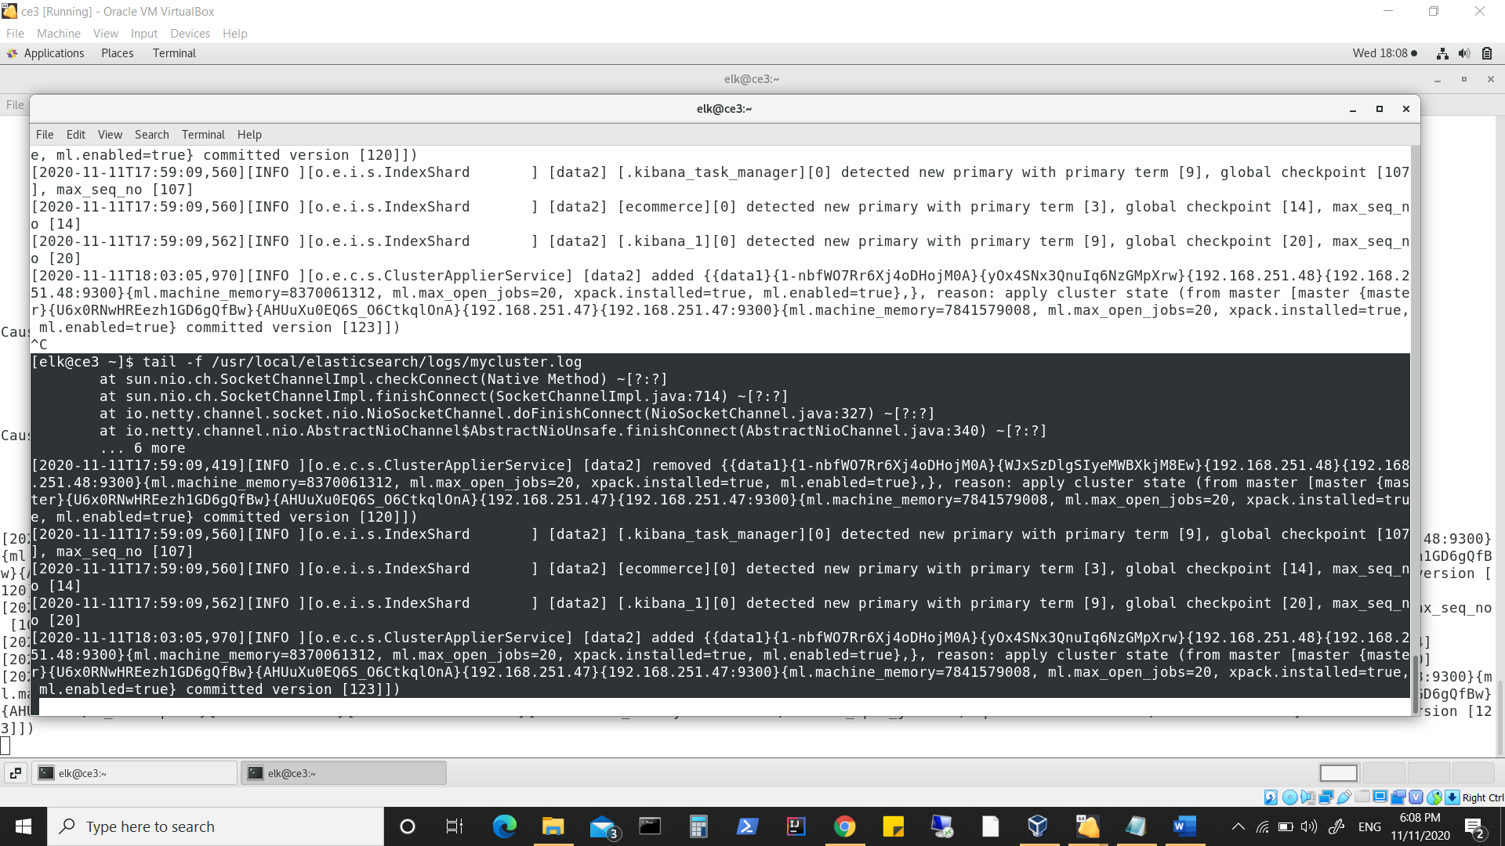

**Summarizing up till now :**

**We first had node1(master), node2(data1), node3(data2) where-in all were master eligible and data1 and data2 as datanodes.**

**Increased the replication of ecommerce to 2 and tested which basically left one replica unassigned as we only had 2 datanodes.**

**Restarted node1(master) by enabling it as data.node:true.**

**The pending replica was assigned to it.**

**Again at this point of time, We had node1(master), node2(data1), node3(data2) where in all were master eligible and all were now as datanodes.**

**node2(data1), was also holding primary shards of indexes.**

**Stopped node2(data1) .**

**As a result node1(master) became the master and was holding primary shards for all indexes.**

**Node3(data2) was holding other replica.**

**One replica remained unassigned (as node2(data1) was brought down)**

**Again restarted data1 and replicas were reassigned.**

**There can be 2 reasons of why primary shard was assigned to node1(master)**

* **Since it is master of cluster and also acting as datanode ( so that read/writes can happen**
* **fastest when data node is closest to master node)**
* **Since it was recently made the datanode , so should have latest replica which qualifies it to become primary shard replica holding node.**

**Can be proven if now node1(master) is turned off and data1(node2) will probably become master and again have primary shards. Also for the reason that no changes were made to index and node3(data2) has the oldest written replica.**

**If after stopping node1(master), node2(data1) becomes primary and holds primary shards then primary shard allocation is aligned to node becoming master.**

**Check**

**Stopped node1(master)**

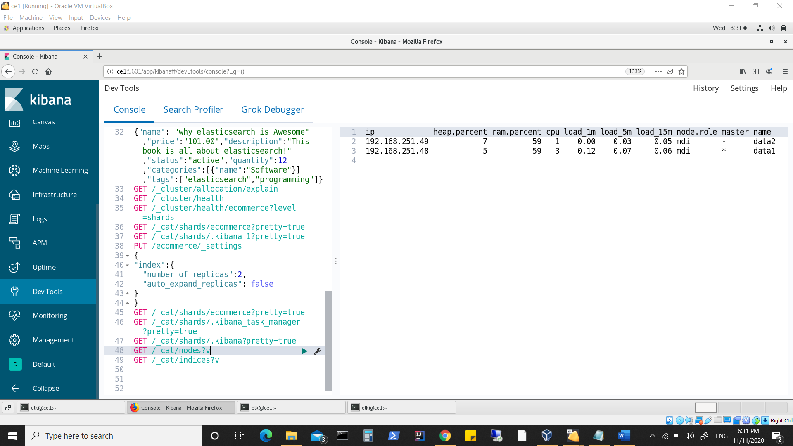

**Data1 becomes master node , however the primary shard is not assigned to node holding master role, infact is assigned to other node i.e. node3(data2)**

**Indexes are now unassigned**

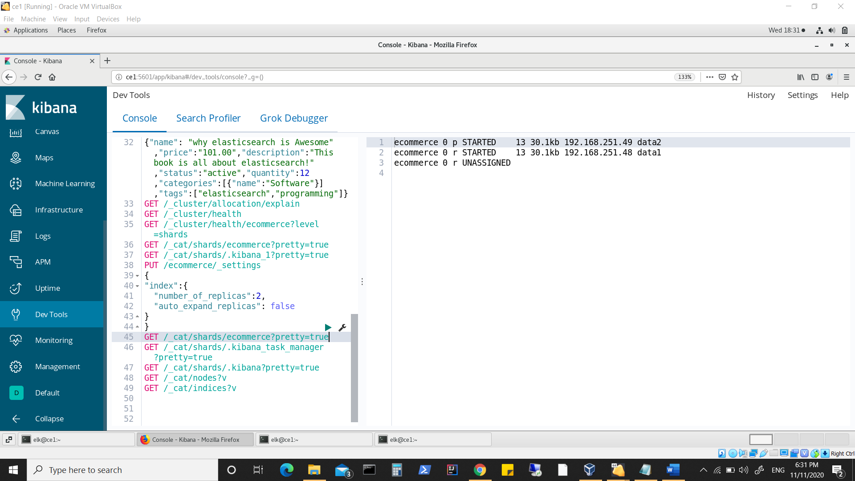

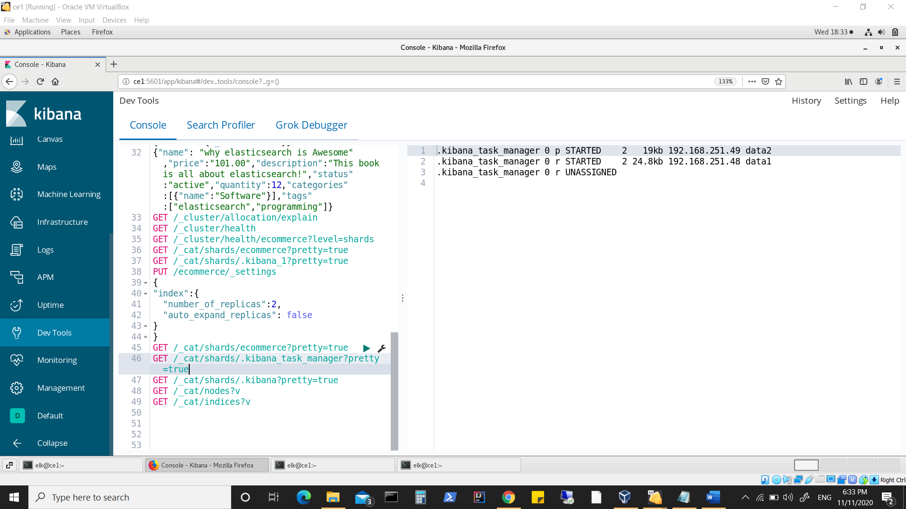

**But notice:**

**Data2(node3) holds primary shard while the data1(node2) is acting as master**

**Thus shard allocation has nothing to do with which node is acting as master.**

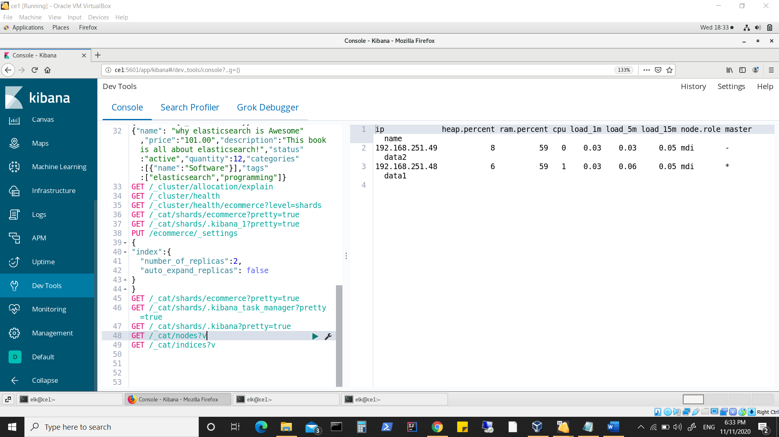

**Restarting node1(master) which takes care of unassigned replicas.**

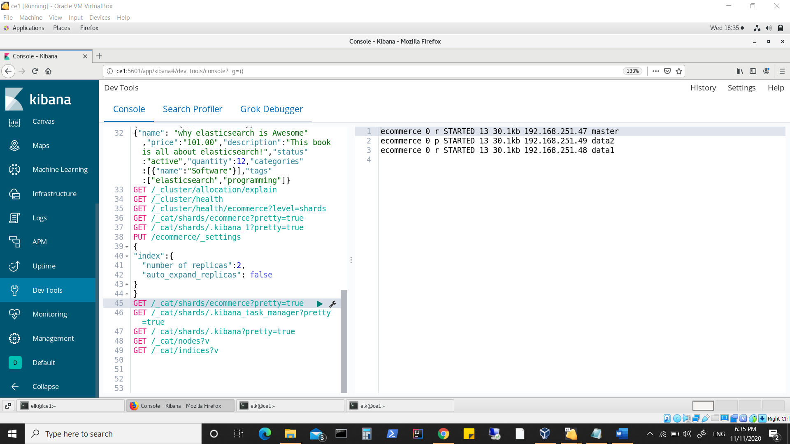

**Made a bulk update**

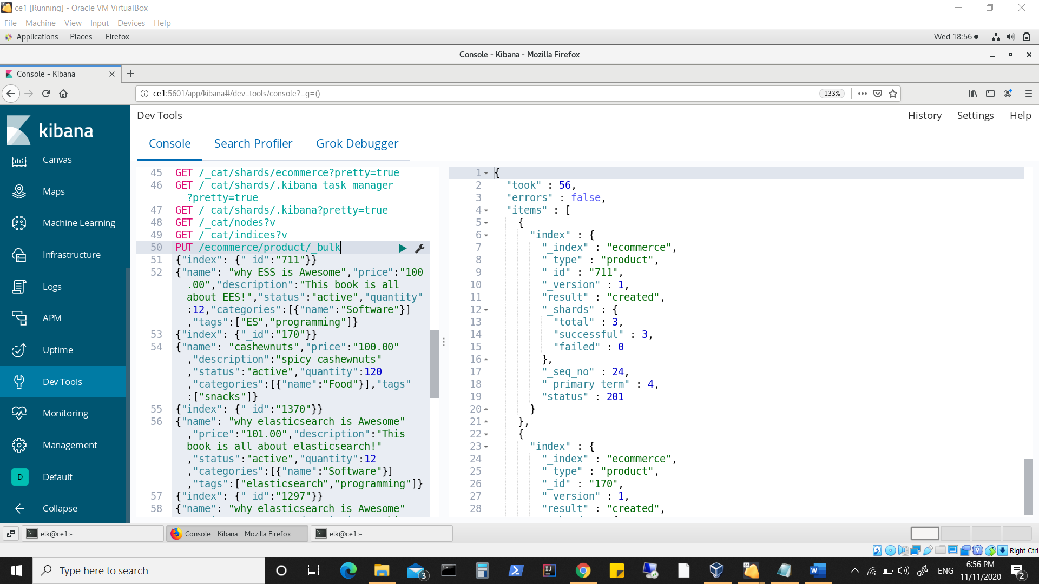

**Shutdown node containing master replica (node3) as soon as update was done.**

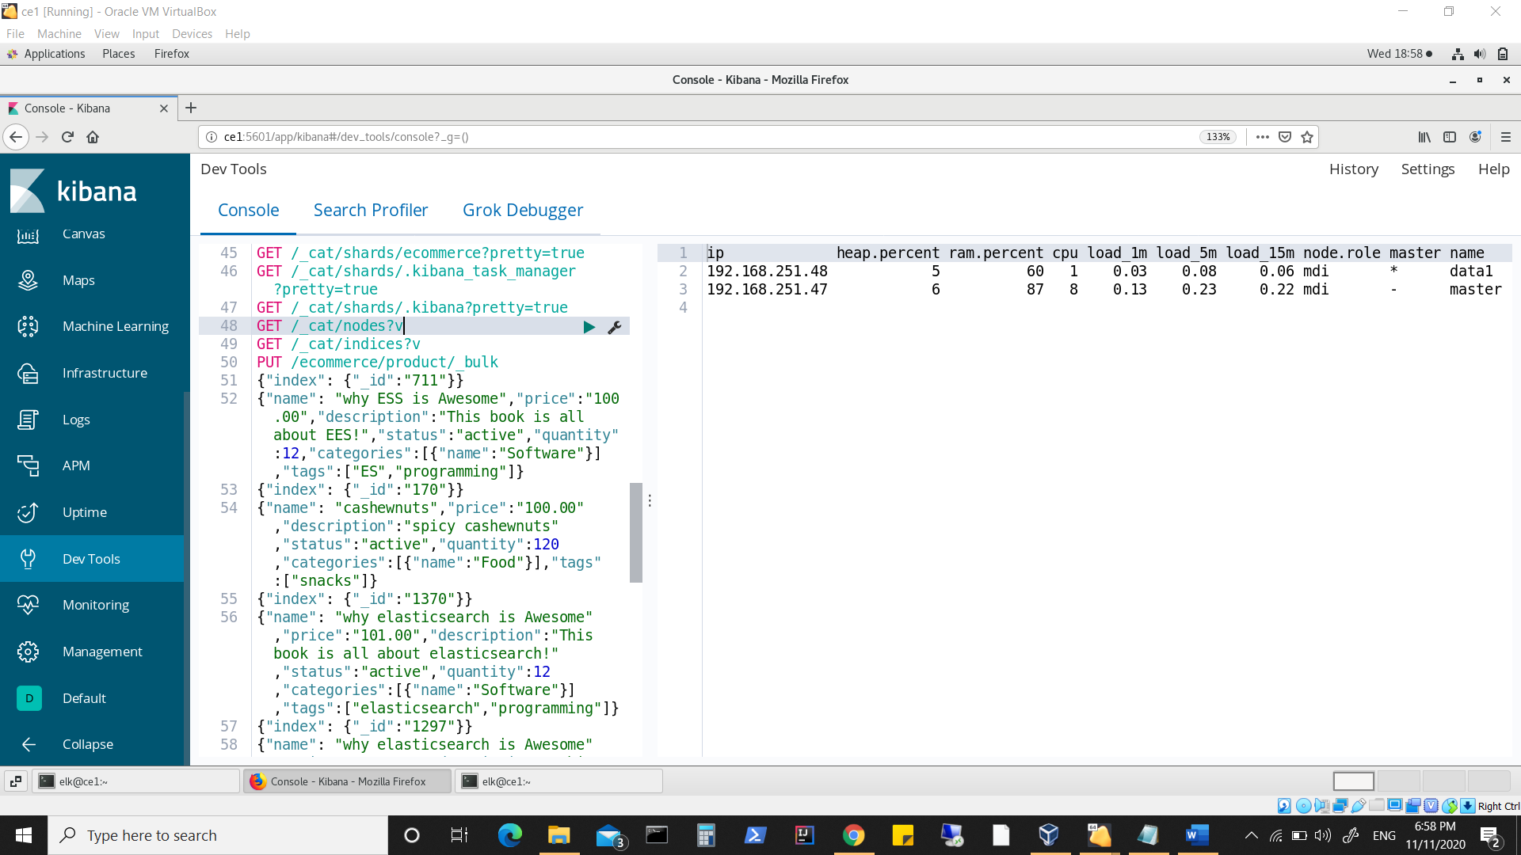

**Primary shard is shifted now to node1(master) which was recently started.**

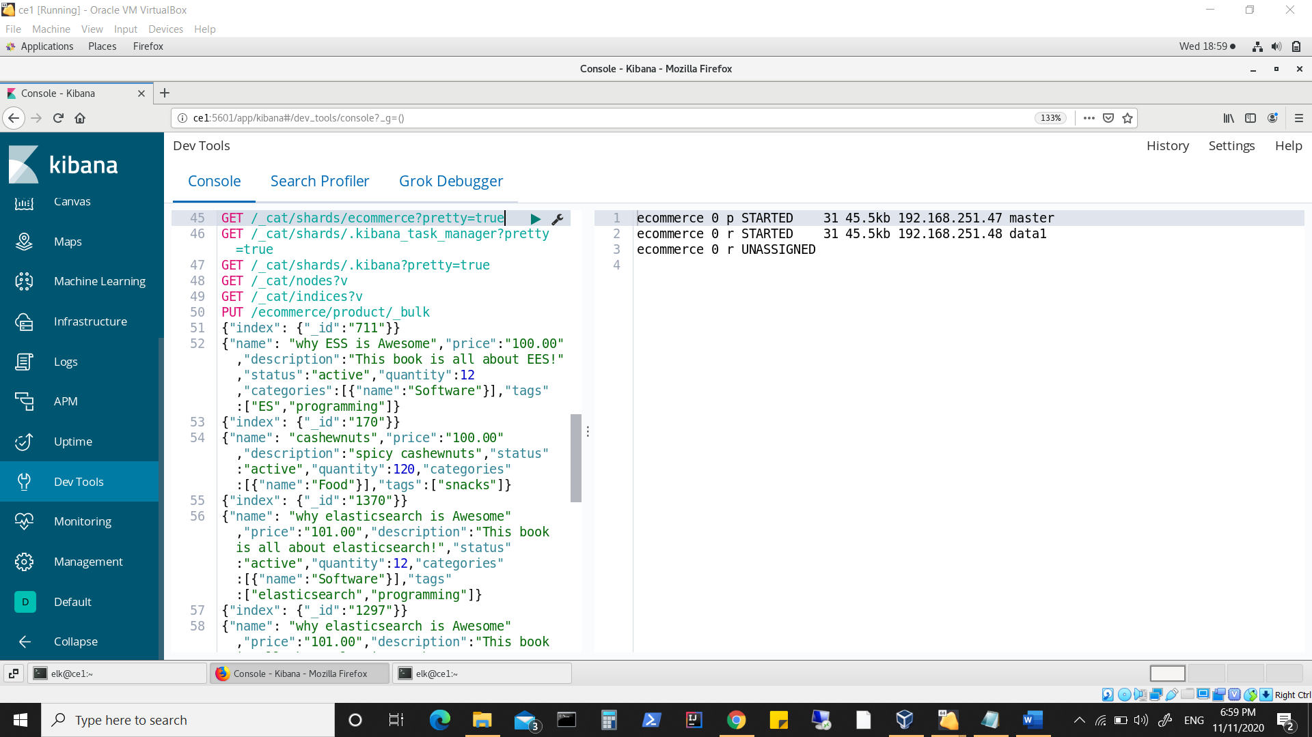

**Reading the last updated document**

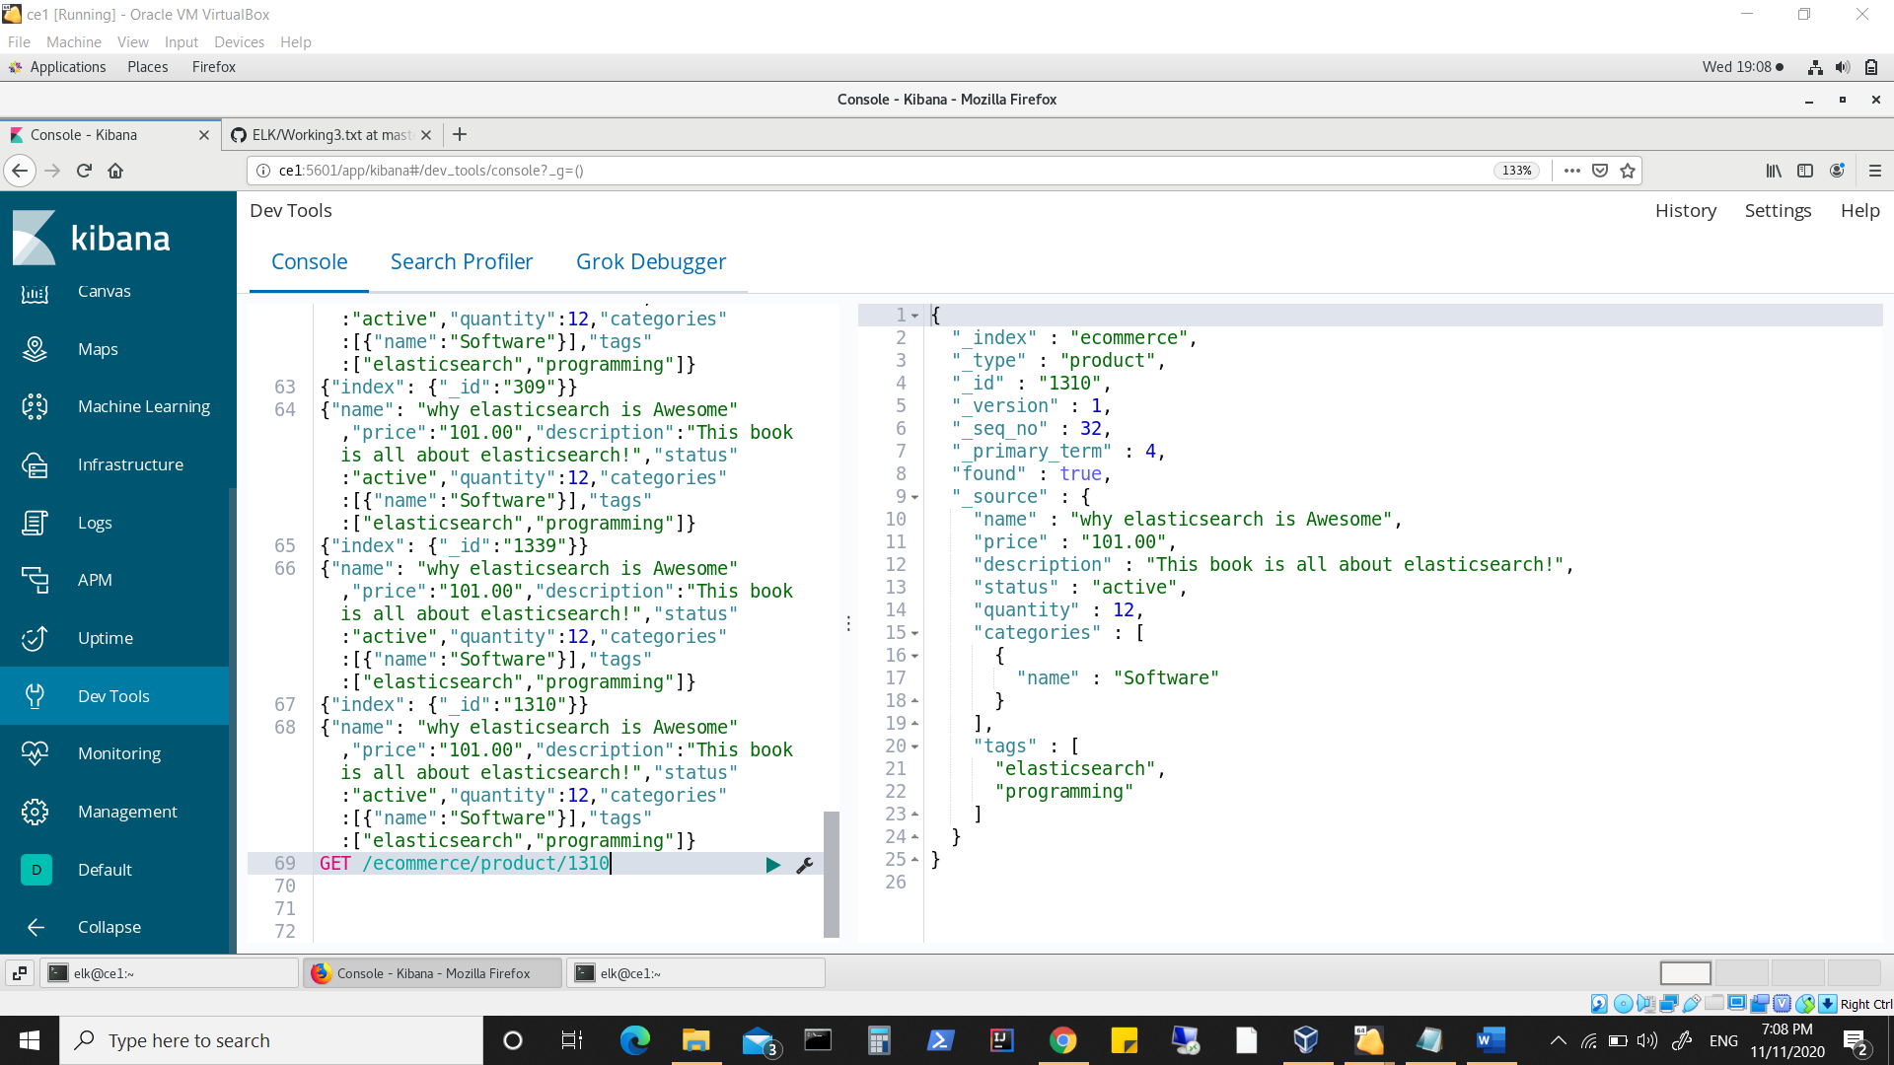

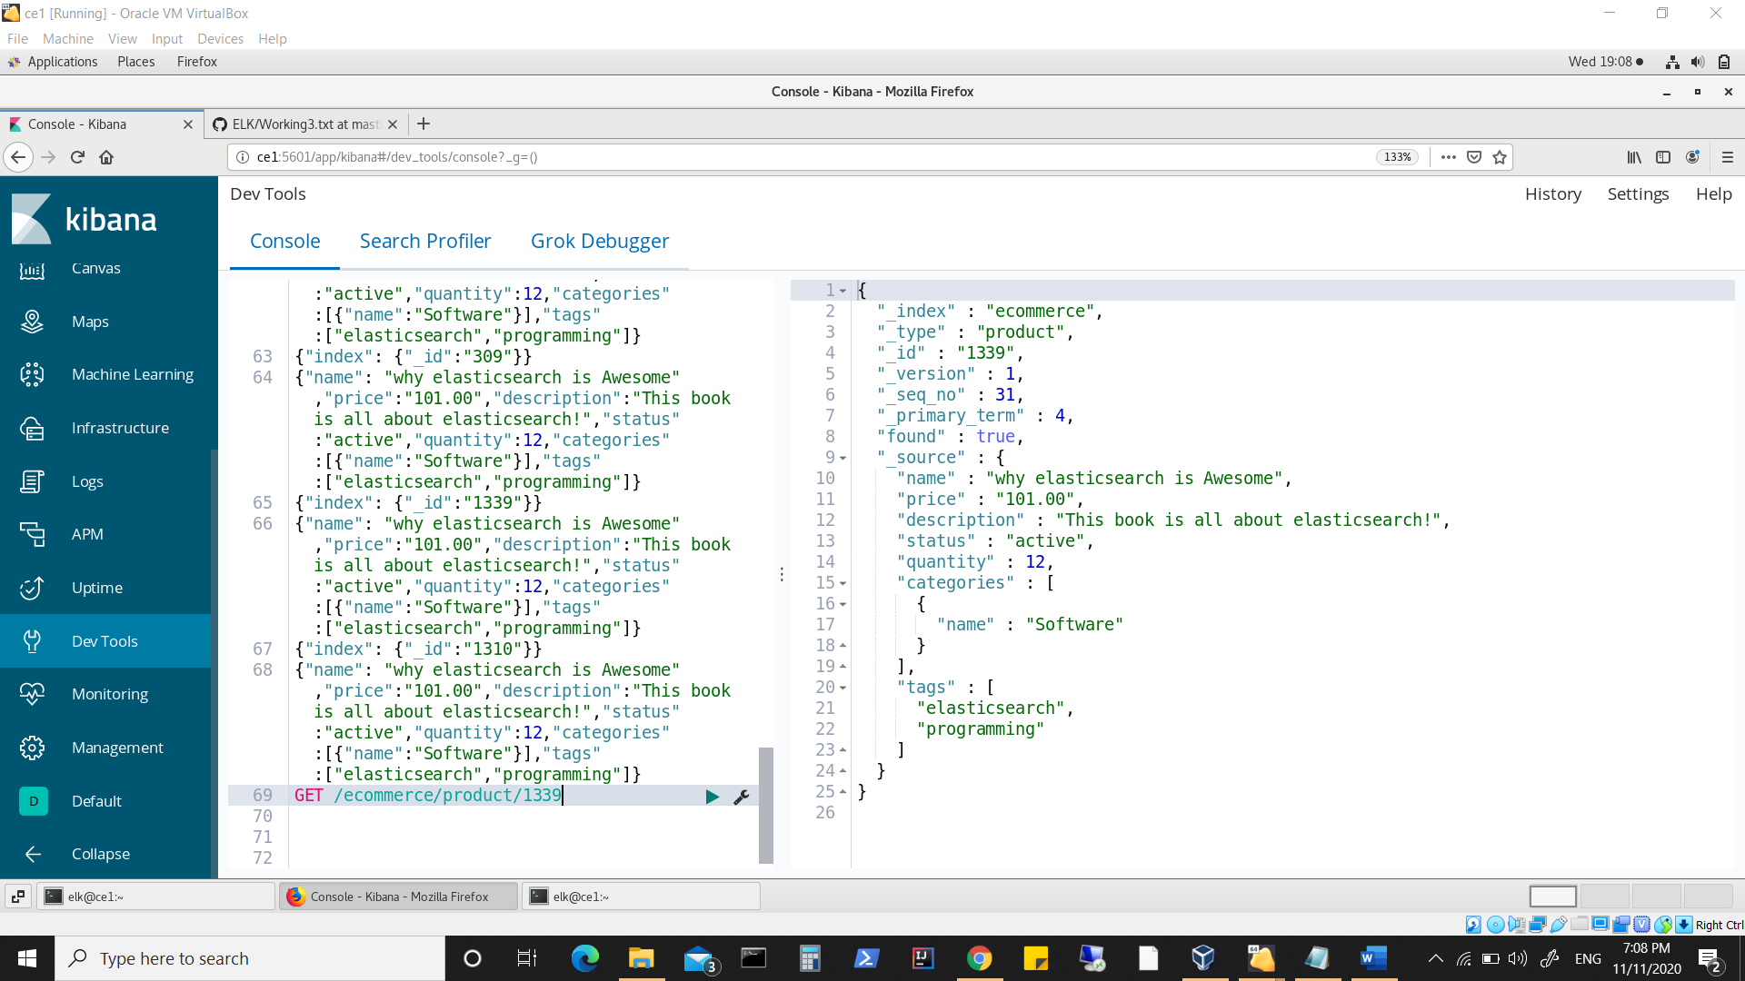

**Looking into log of node1(master) which holds primary shards:**

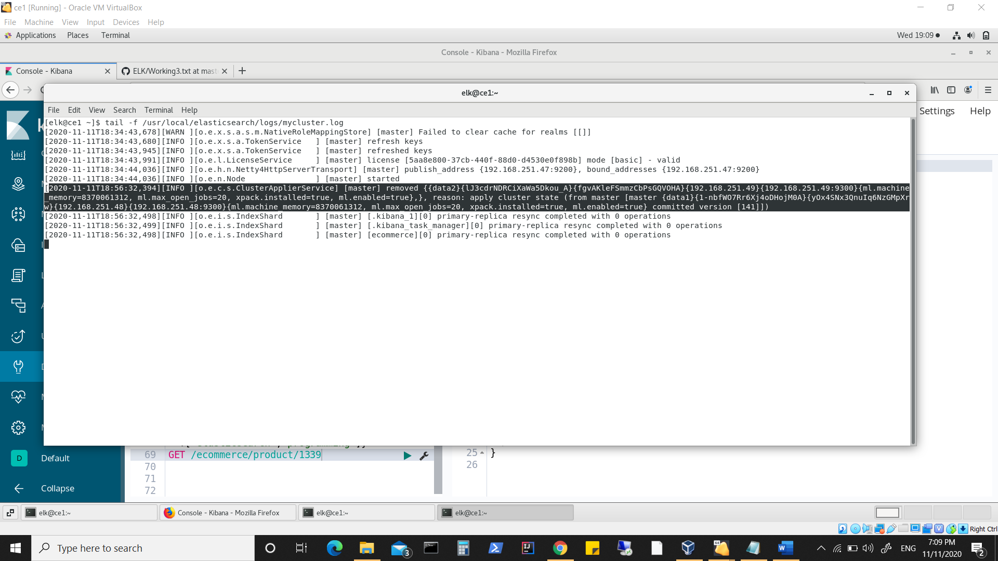

**Notice the line which shows committed version. Same can be seen in logs posted earlier in document.**

**Looking into node2(data1) show msg about “scheduling delayed reroute for delayed shards”. A msg usually noticed in node that is acting as master. (when some node fails)**

**Looking at log of data2(node3) which was recently killed**

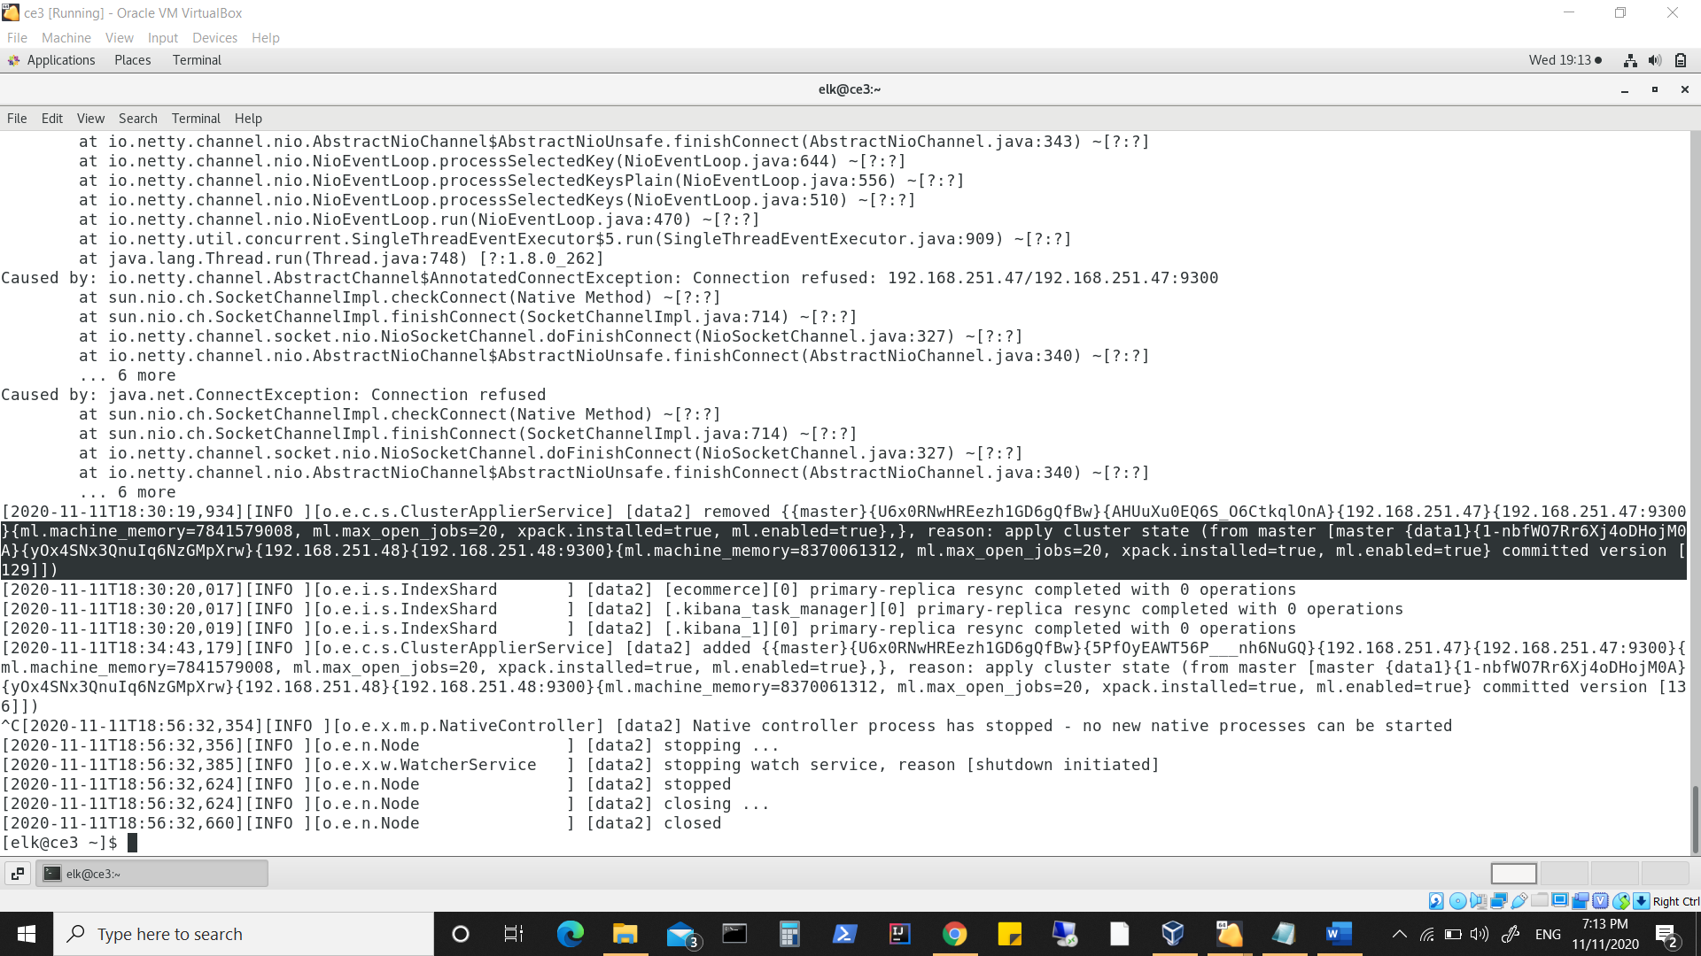

**Look at committed version which is lagging behind.**

**Final run:**

**Starting node3(data2)**

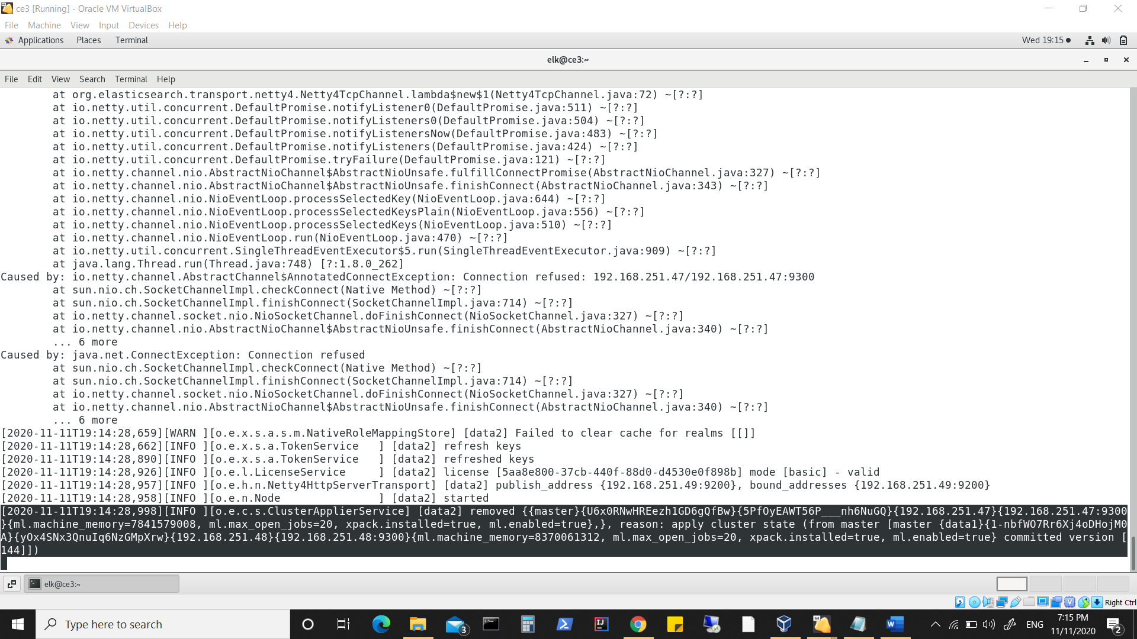

**Has now latest committed version**

**Stopping node1(master) which was also holding primary shard.**

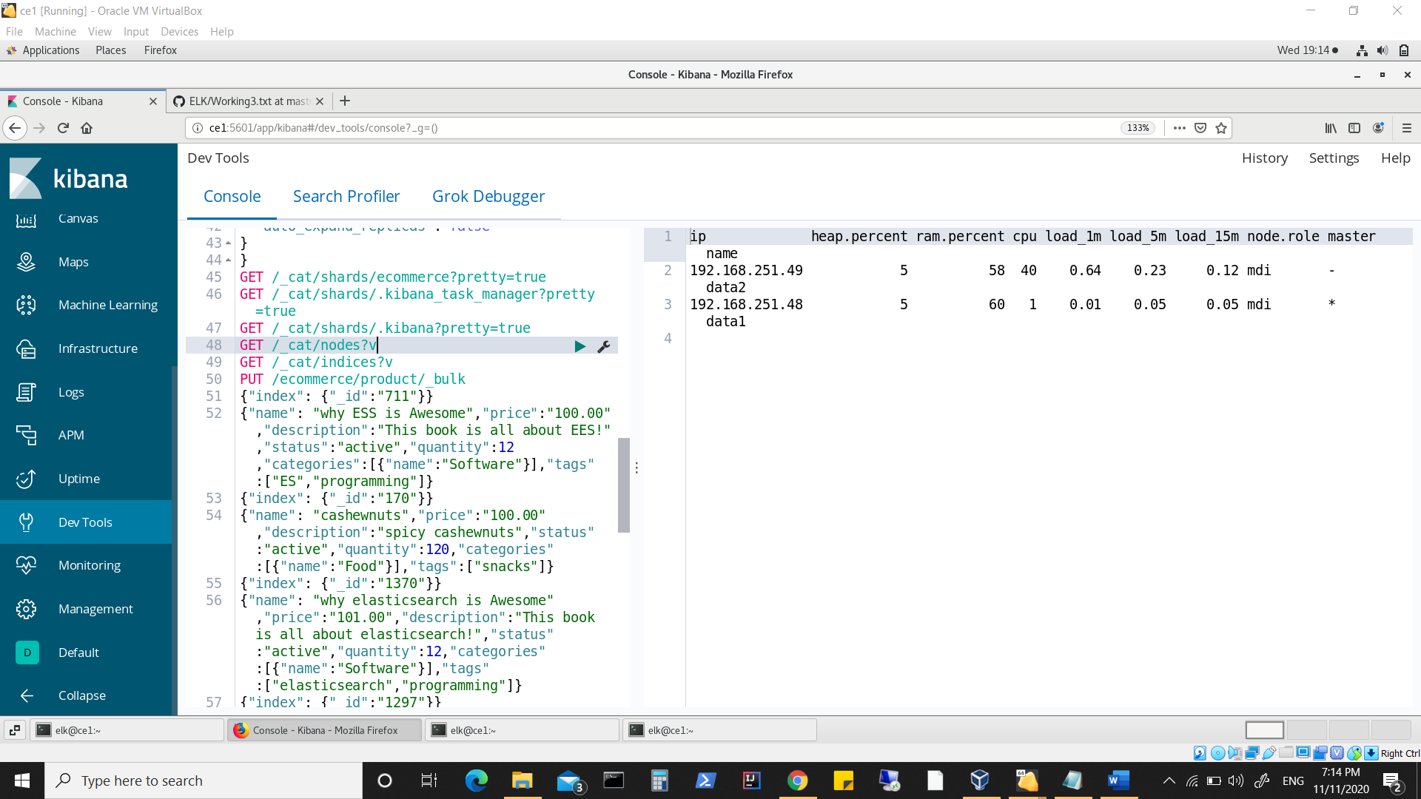

**Notice index status**

**Node2(data1) is master again.**

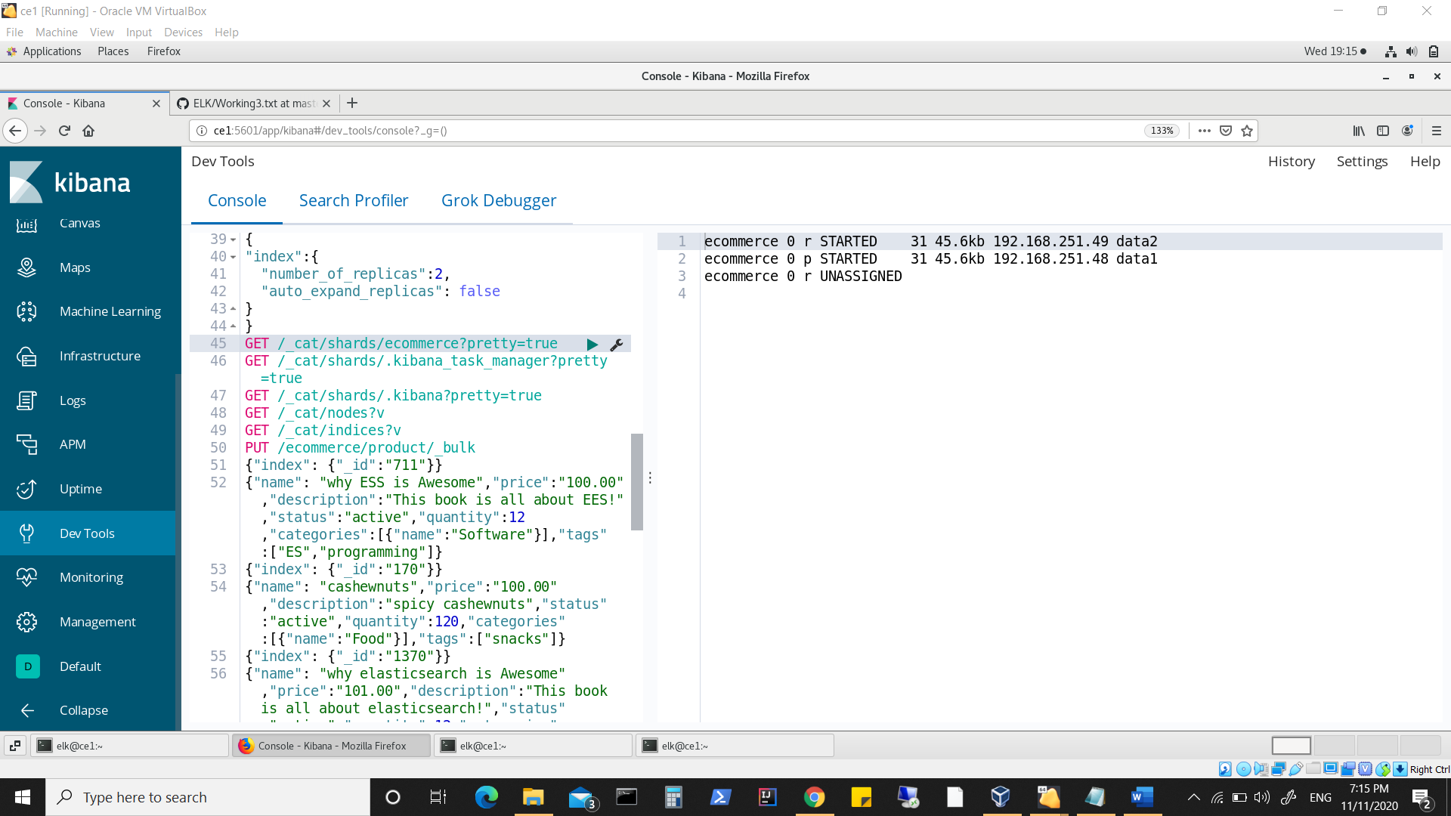

**Now restarting node1(master) should have shards reassigned and have primary shards moved to node3(data2) with latest commit point. (if commit point was reason)**

**Node3(data2) was not chosen for primary shard, instead node2(data1) which was acting as master retains for primary shard.**

**Stopping node1(master) was stopped again.**

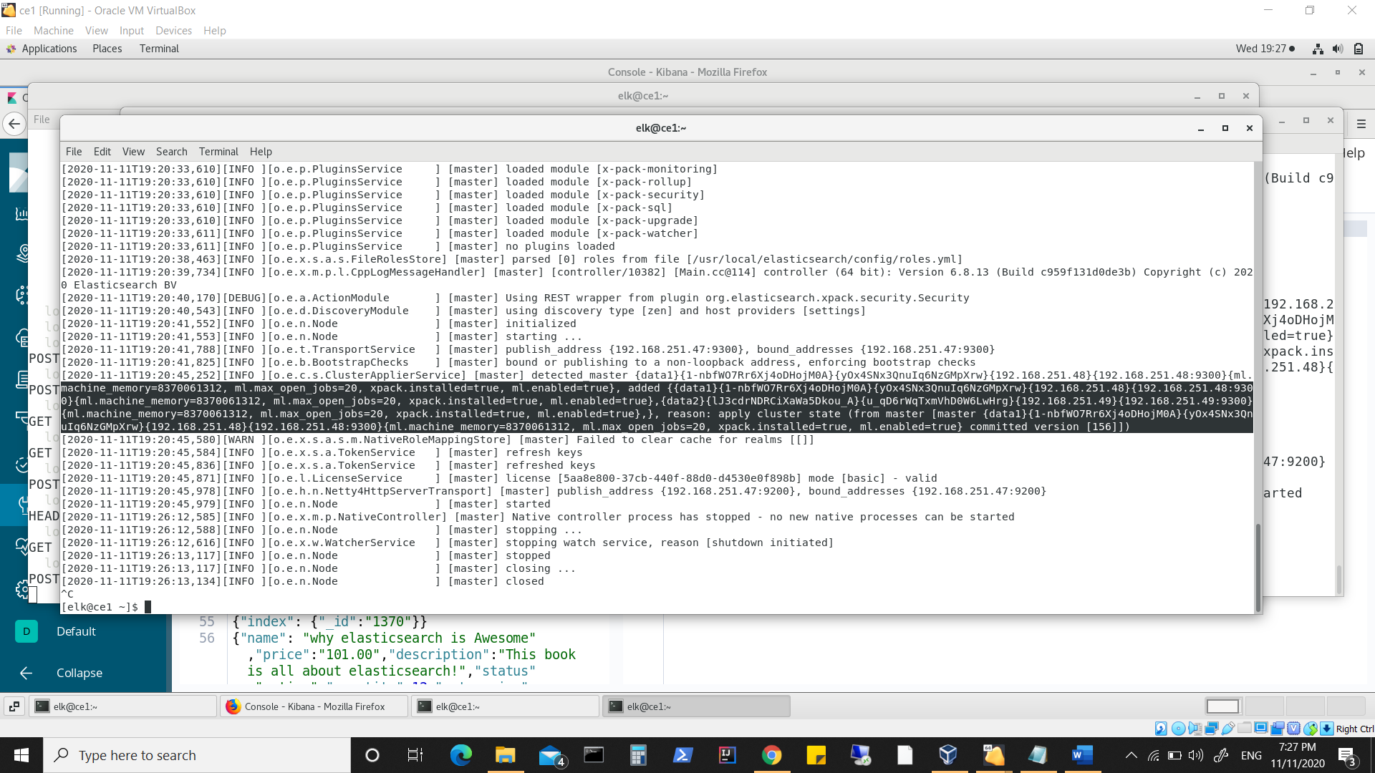

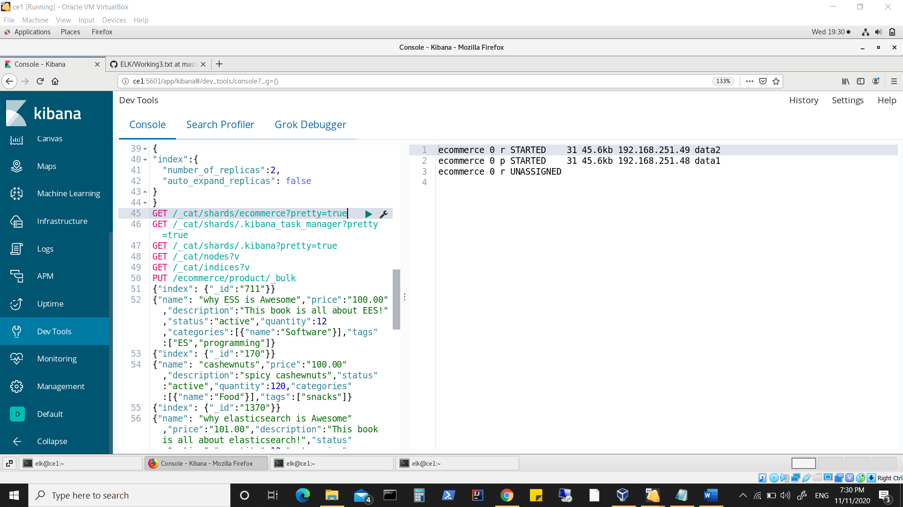

**Primary shard remains on node2(data1)**

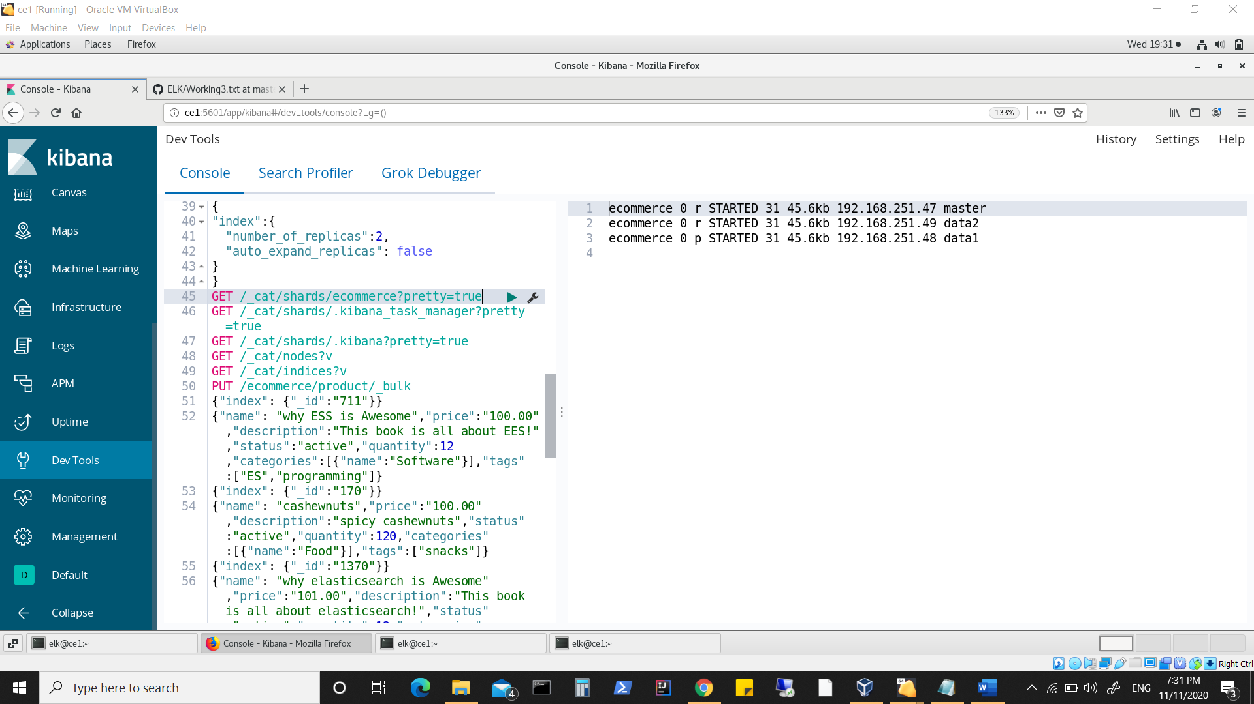

**Node1(master) now shows**

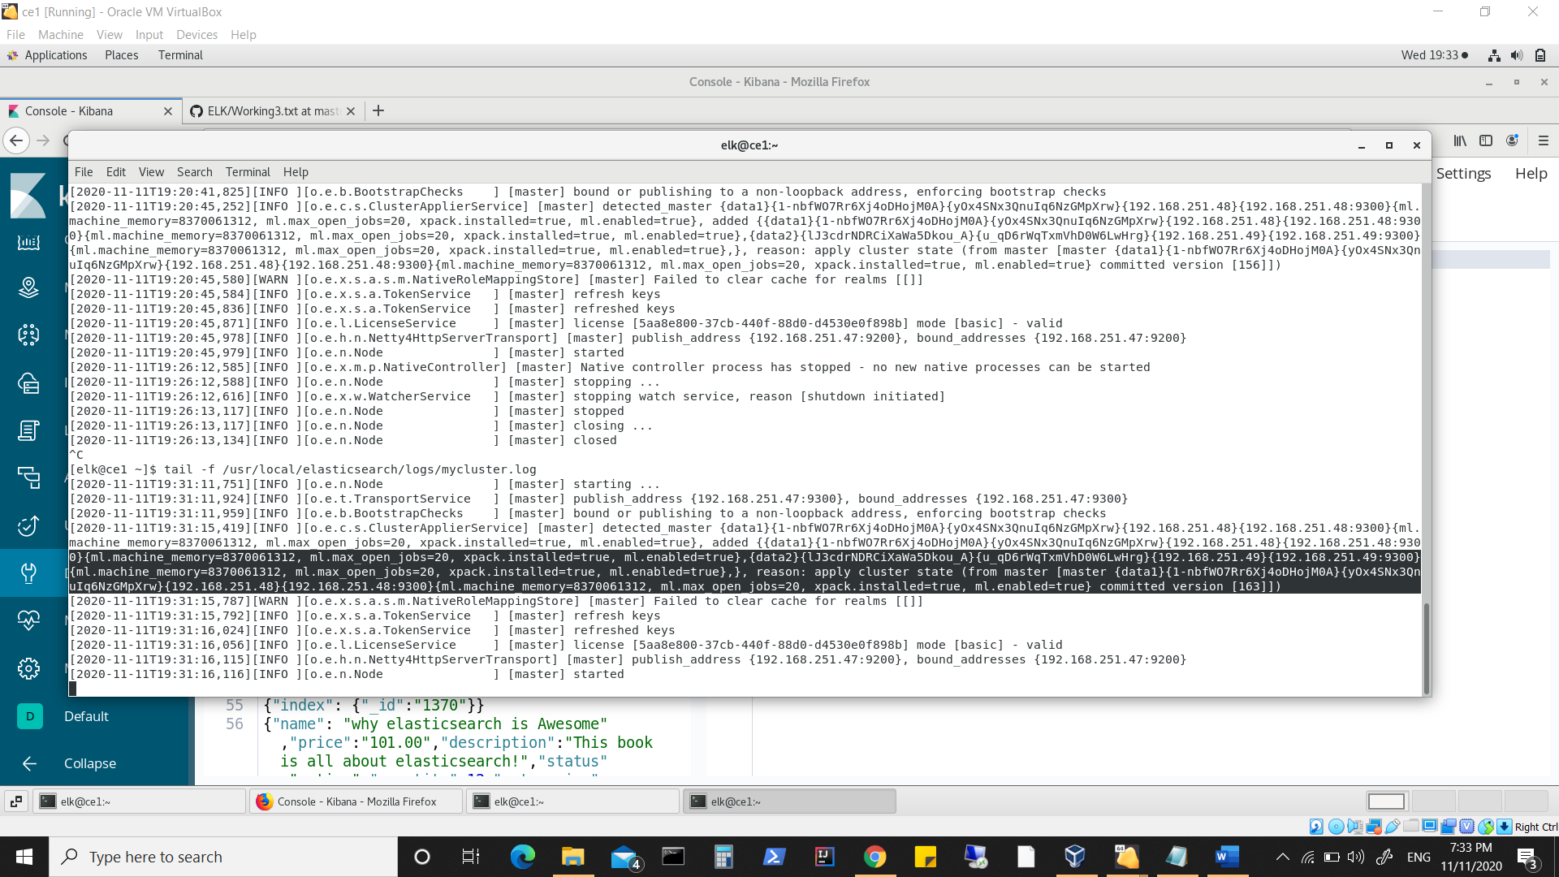

**Node3(data2) now shows**

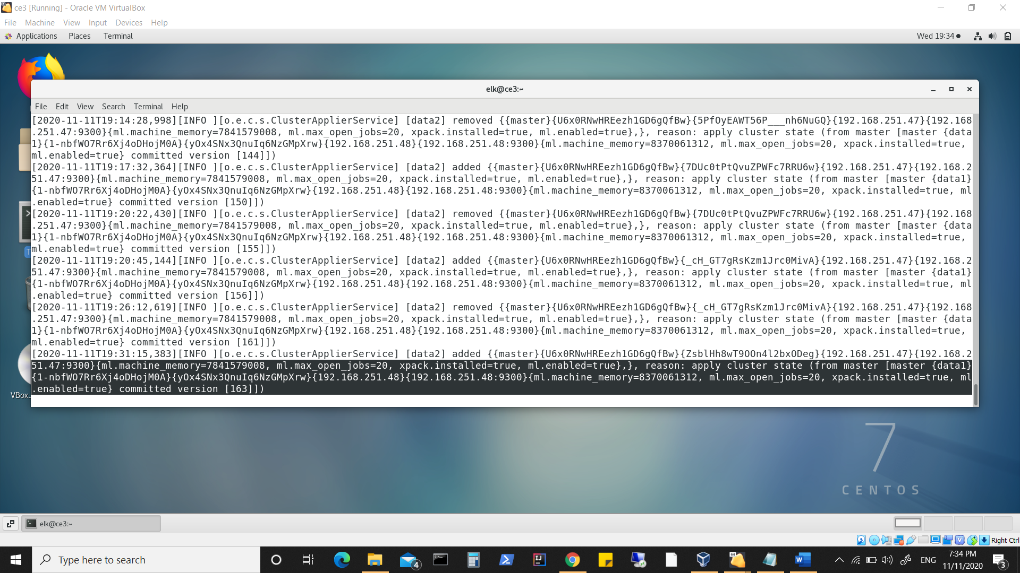

**Stopped data1(master) and now master has shifted to node1(master) and has now the primary shards.**

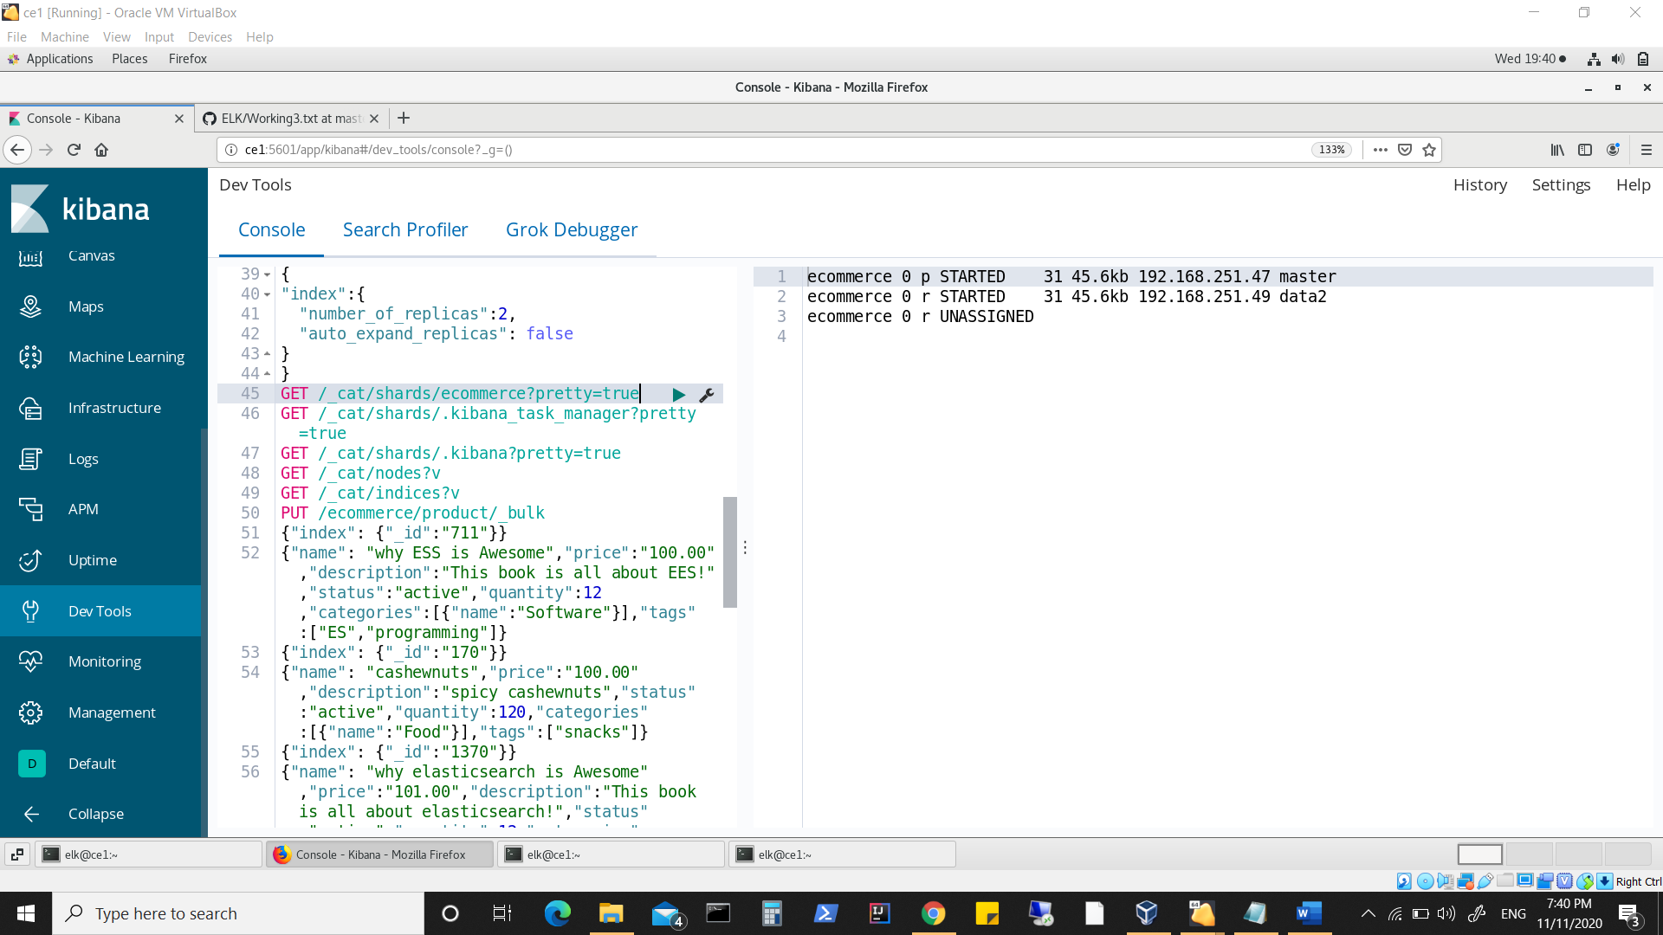

**Node3(data2) shows**

**Notice committed version shows latest (171) and global checkpoint shows 119.**

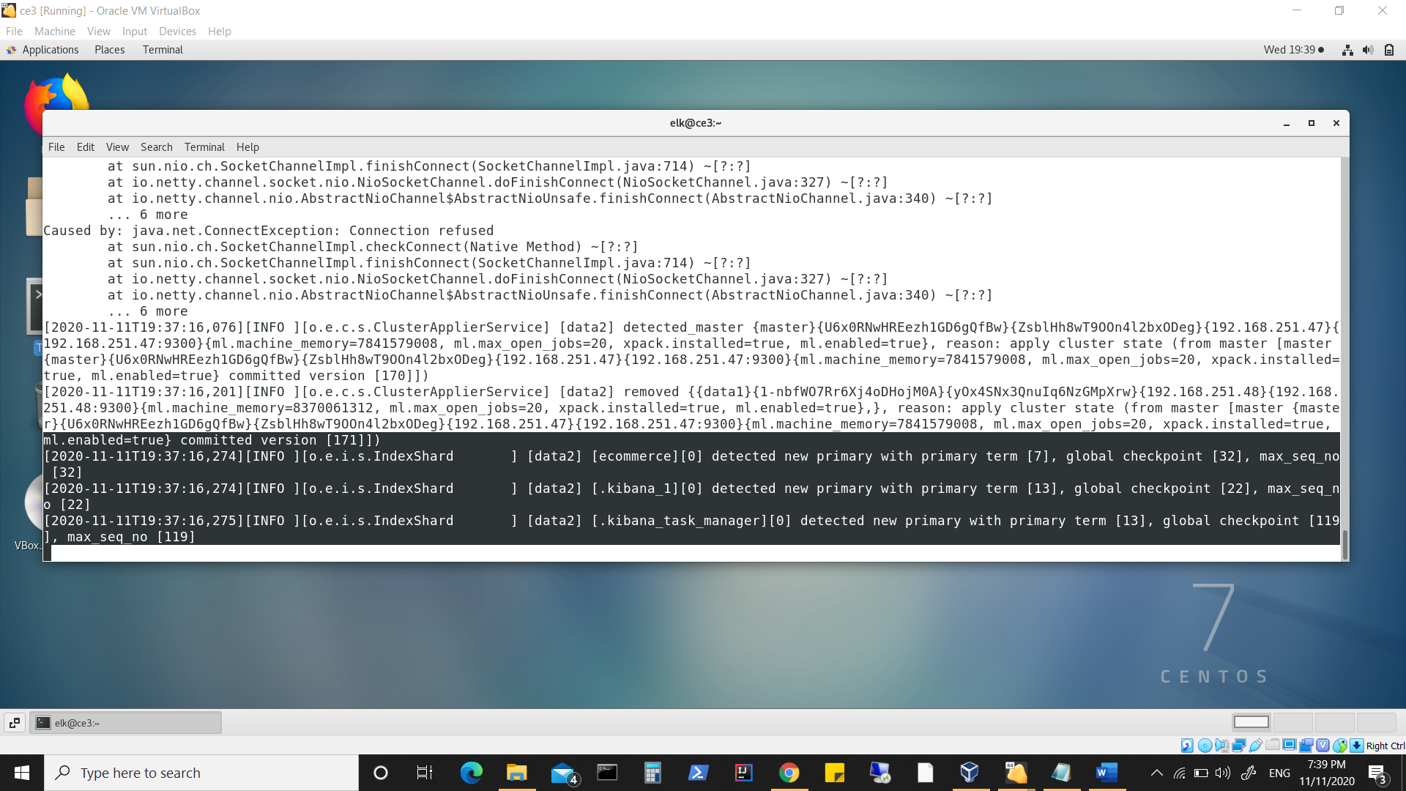

**Node2(data1) shows this after restarting**

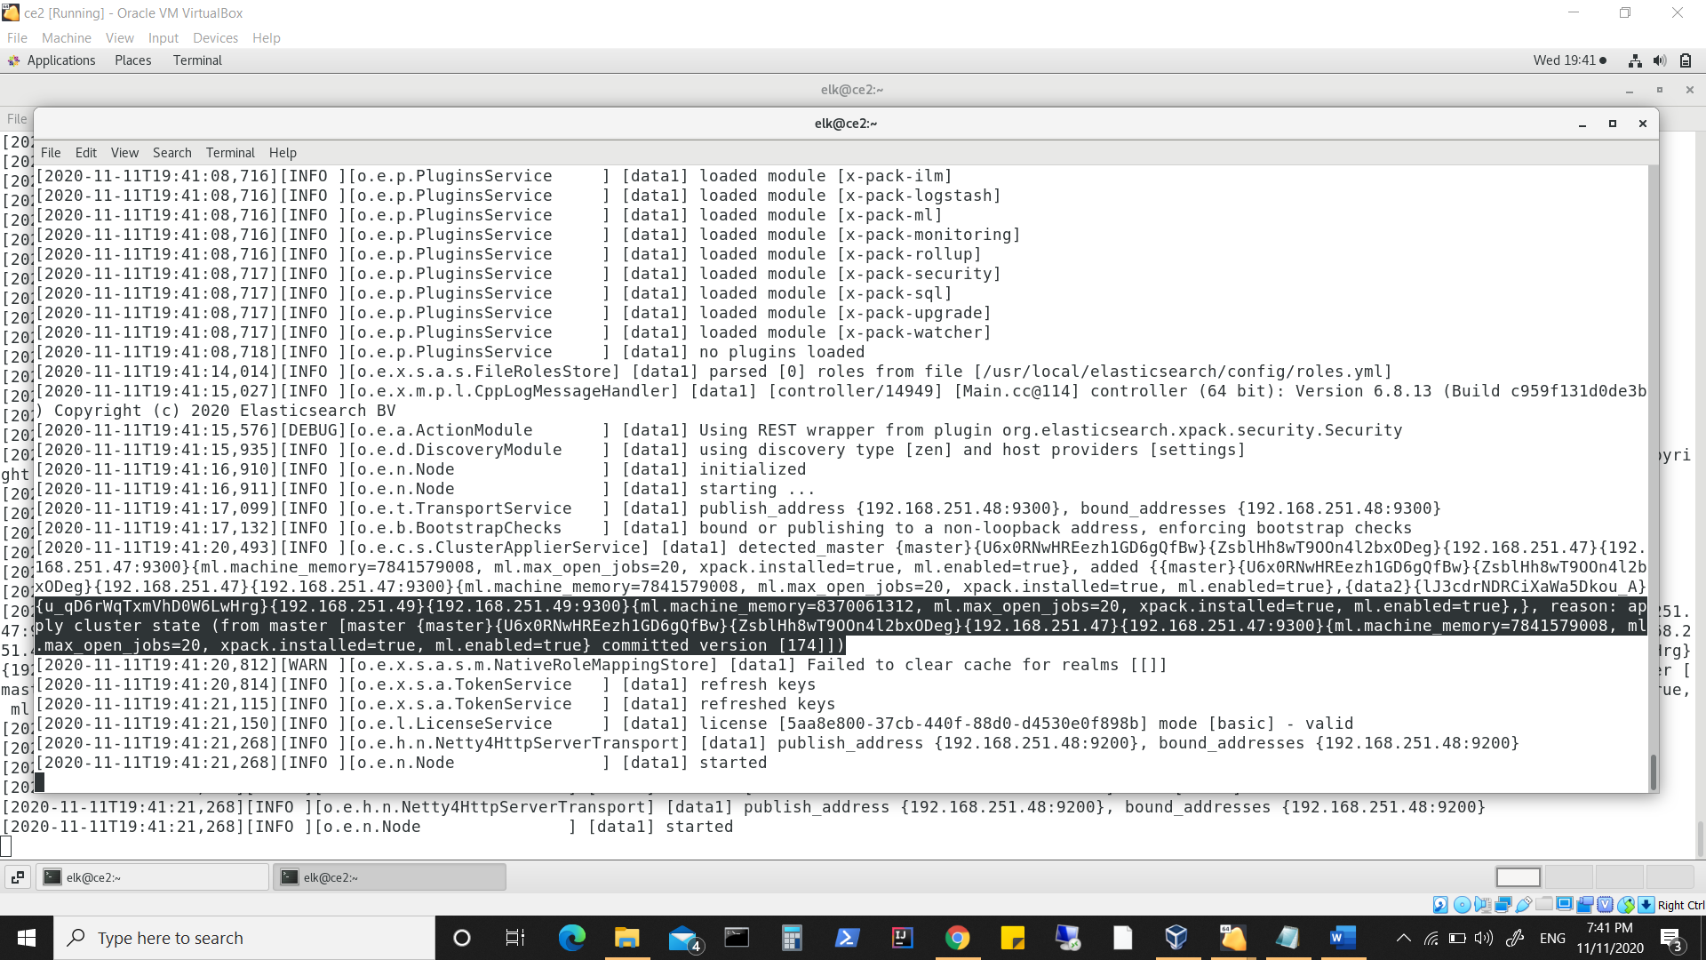

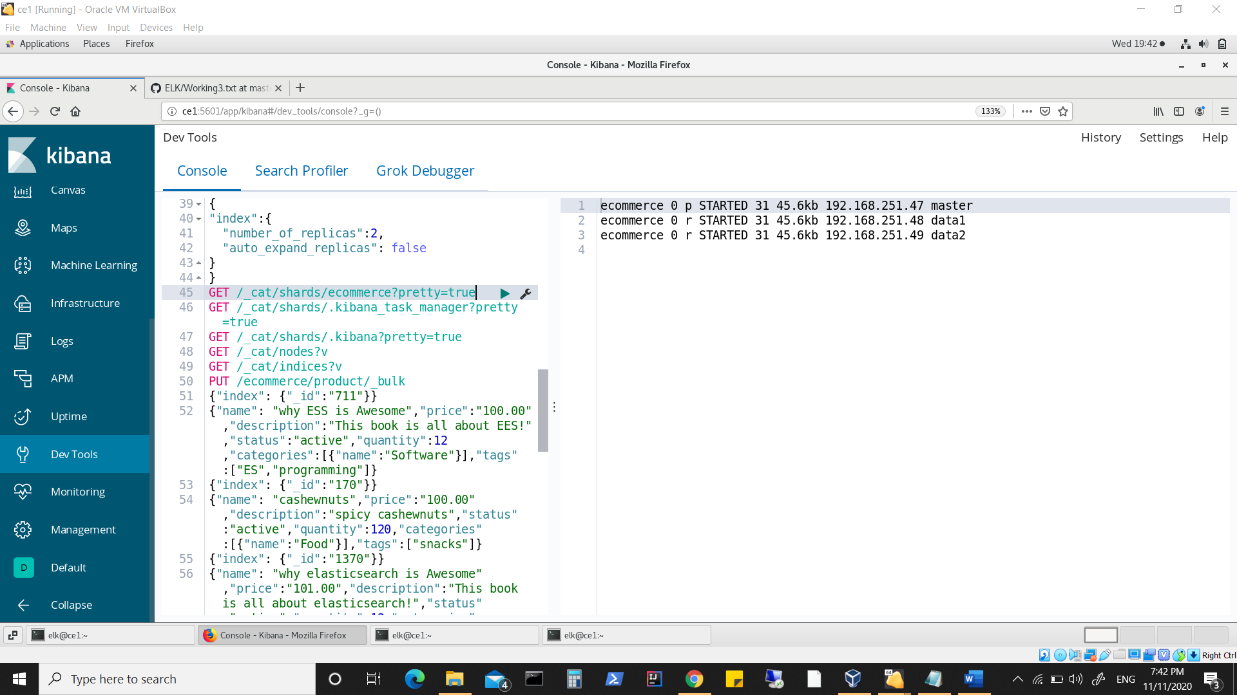

**Stopping n starting node1(master)**

**Shift primary shards and master role to node2(data1)**

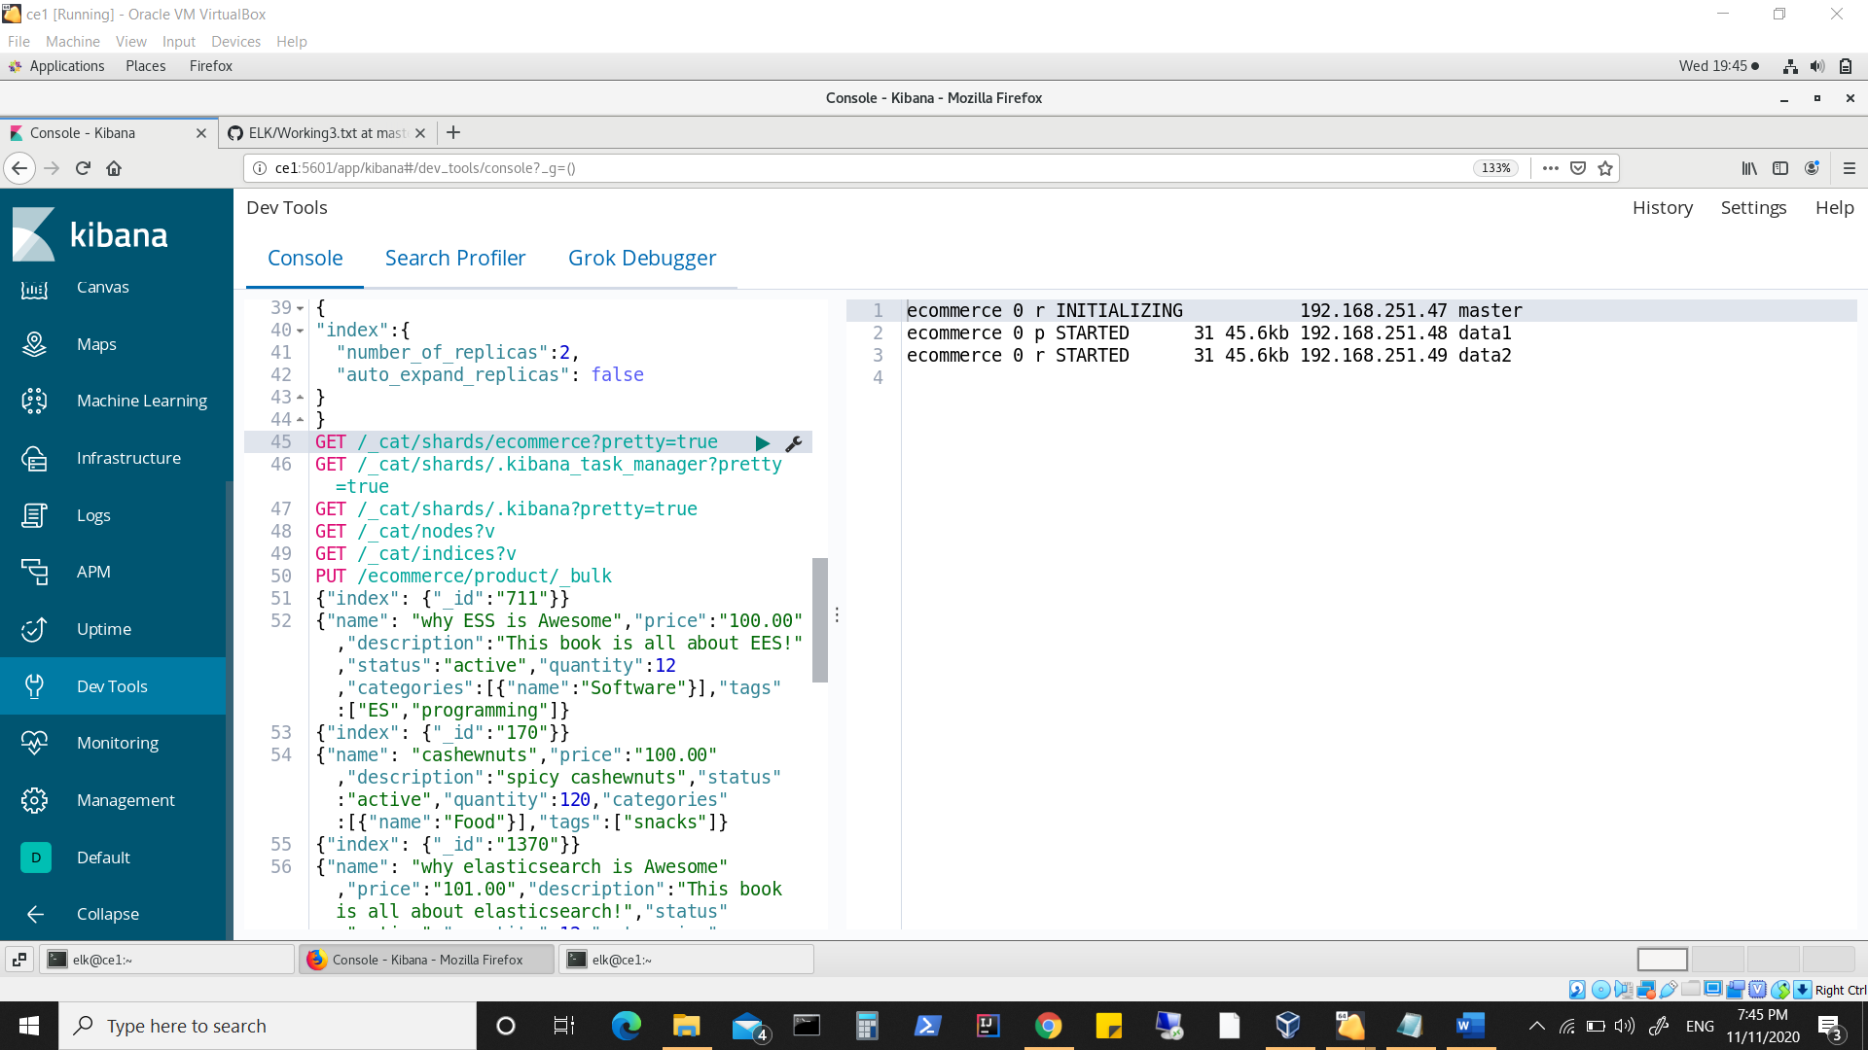

**Note** So many restarts and we notice the primary shard allocation happens to node which retains master status ( & because it was also specified as data.node:true) .**

**The other node (which rarely became master in any previous runs i.e. node3) was also running and available, however was rarely chosen to have ‘primary shard’.**

**Now node1(master) has commit point**

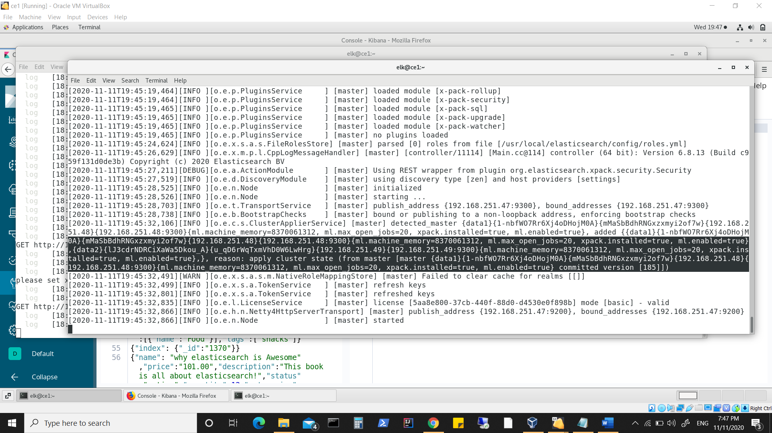

**Data2(node3) also shows same commitment**

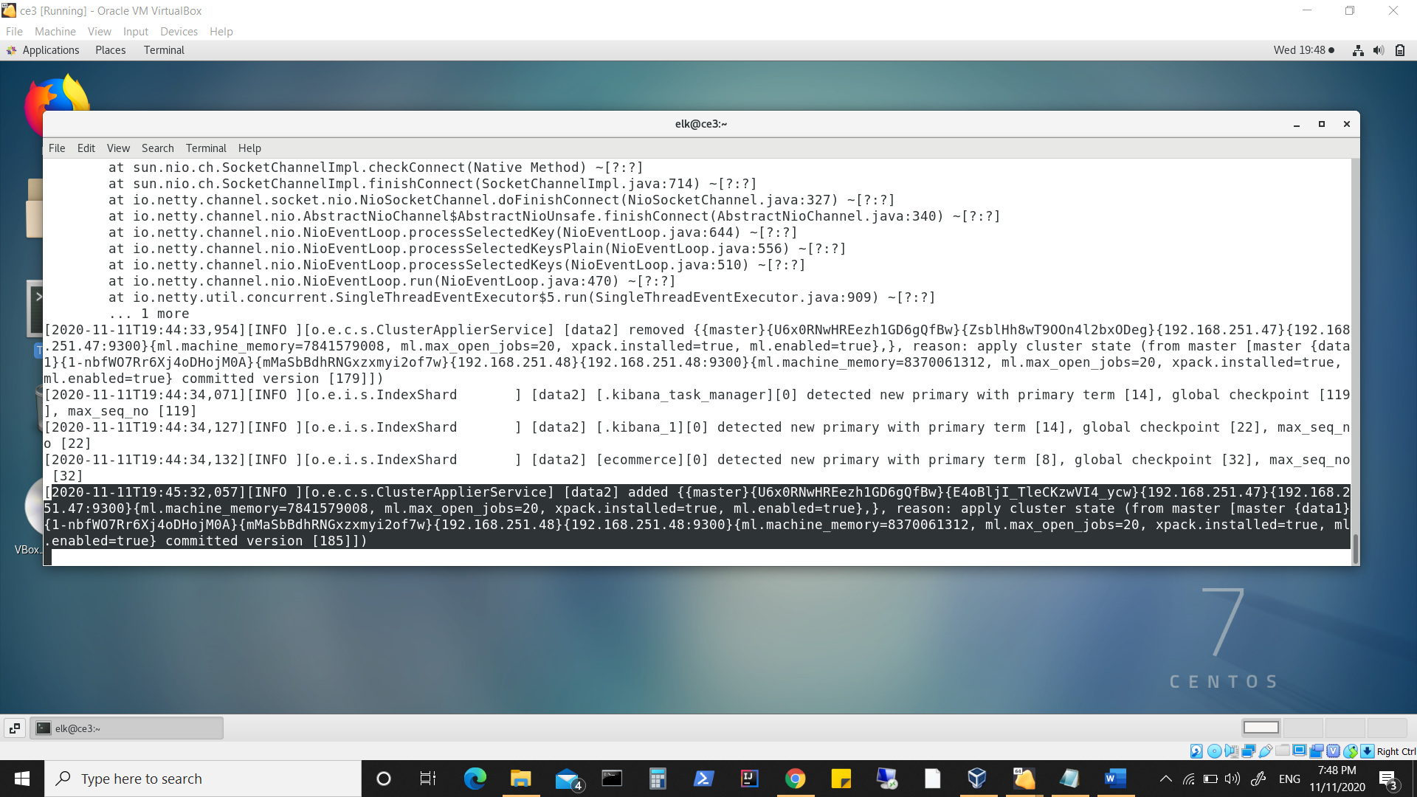

**Stopping all nodes and intentionally starting node3(data2) first (with an intention if it can assume master role)**

**Node3 shows**

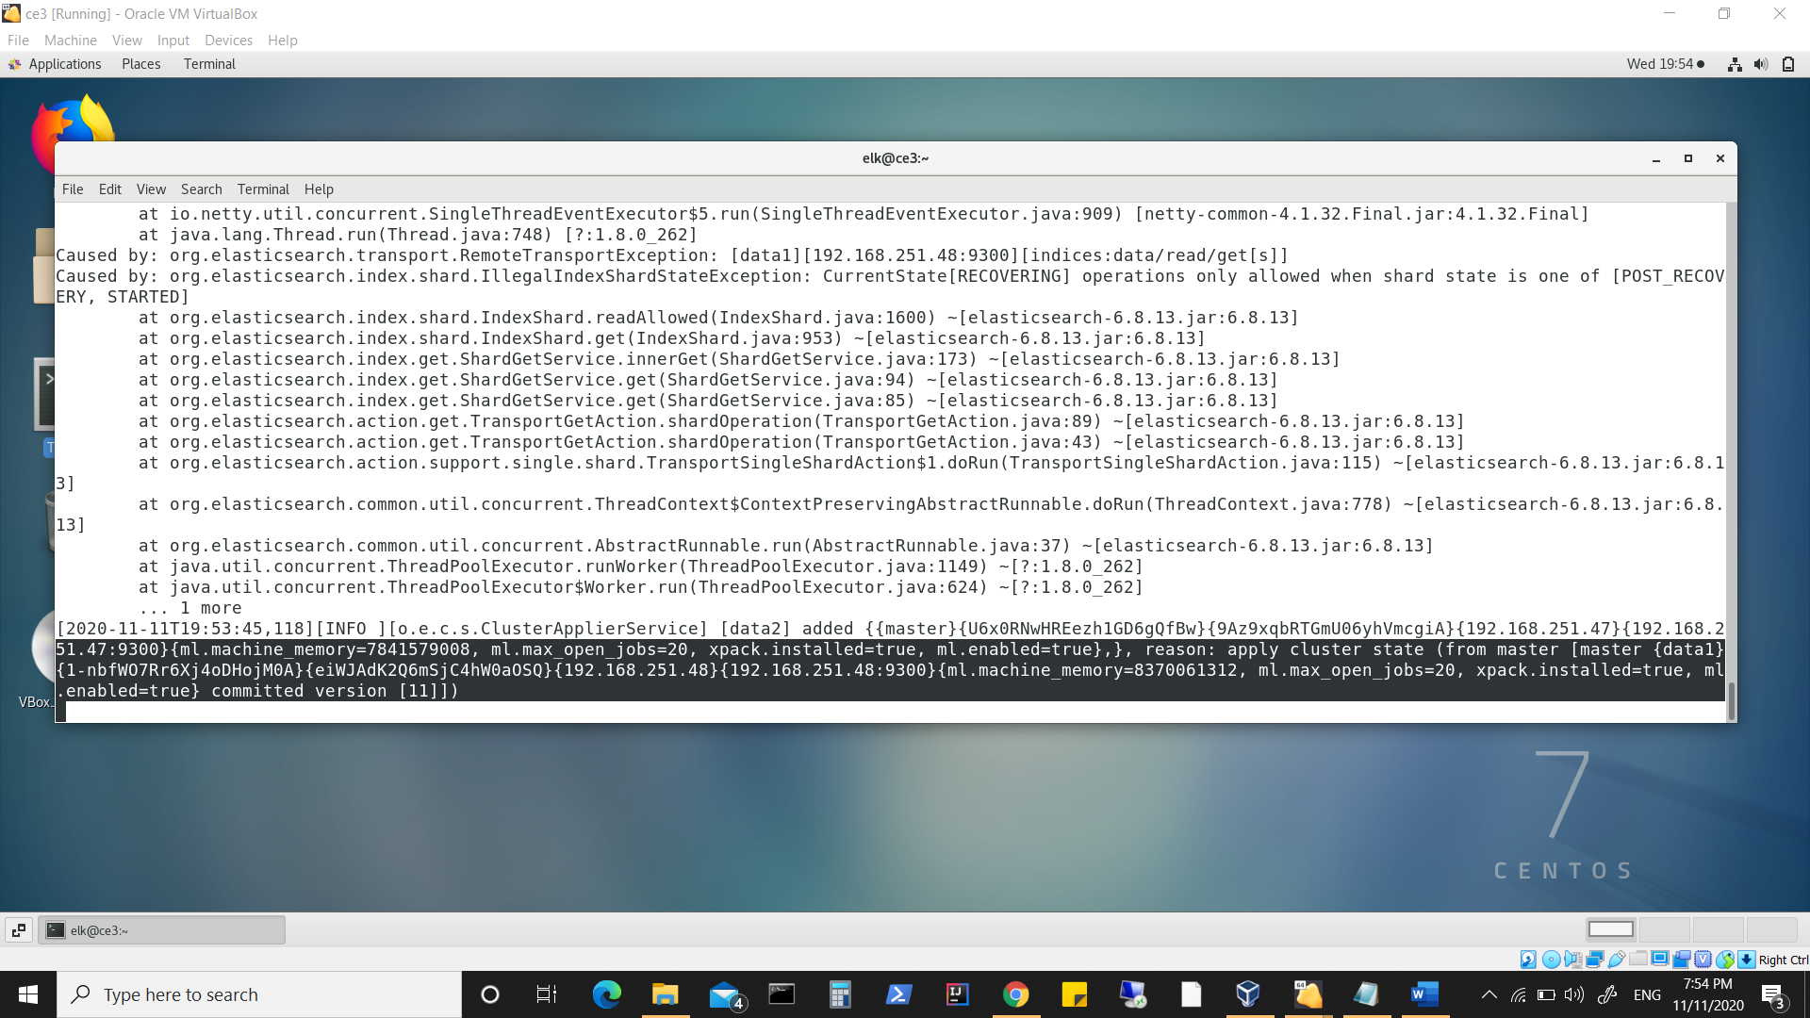

**Node2(data1) shows**

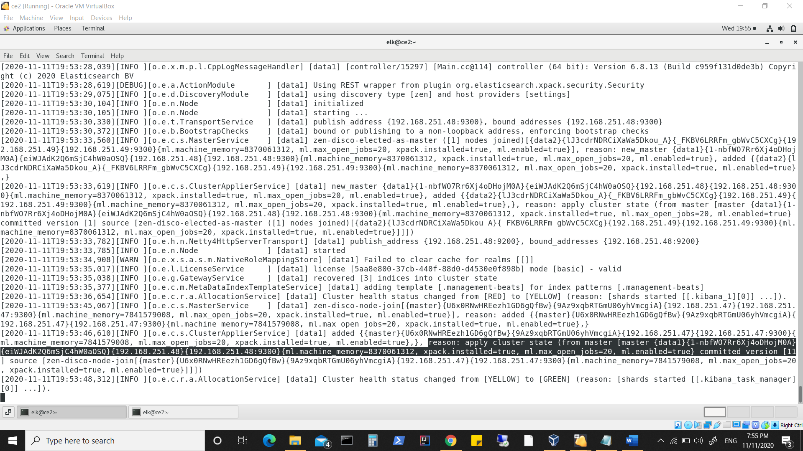

**Node1(master) shows**

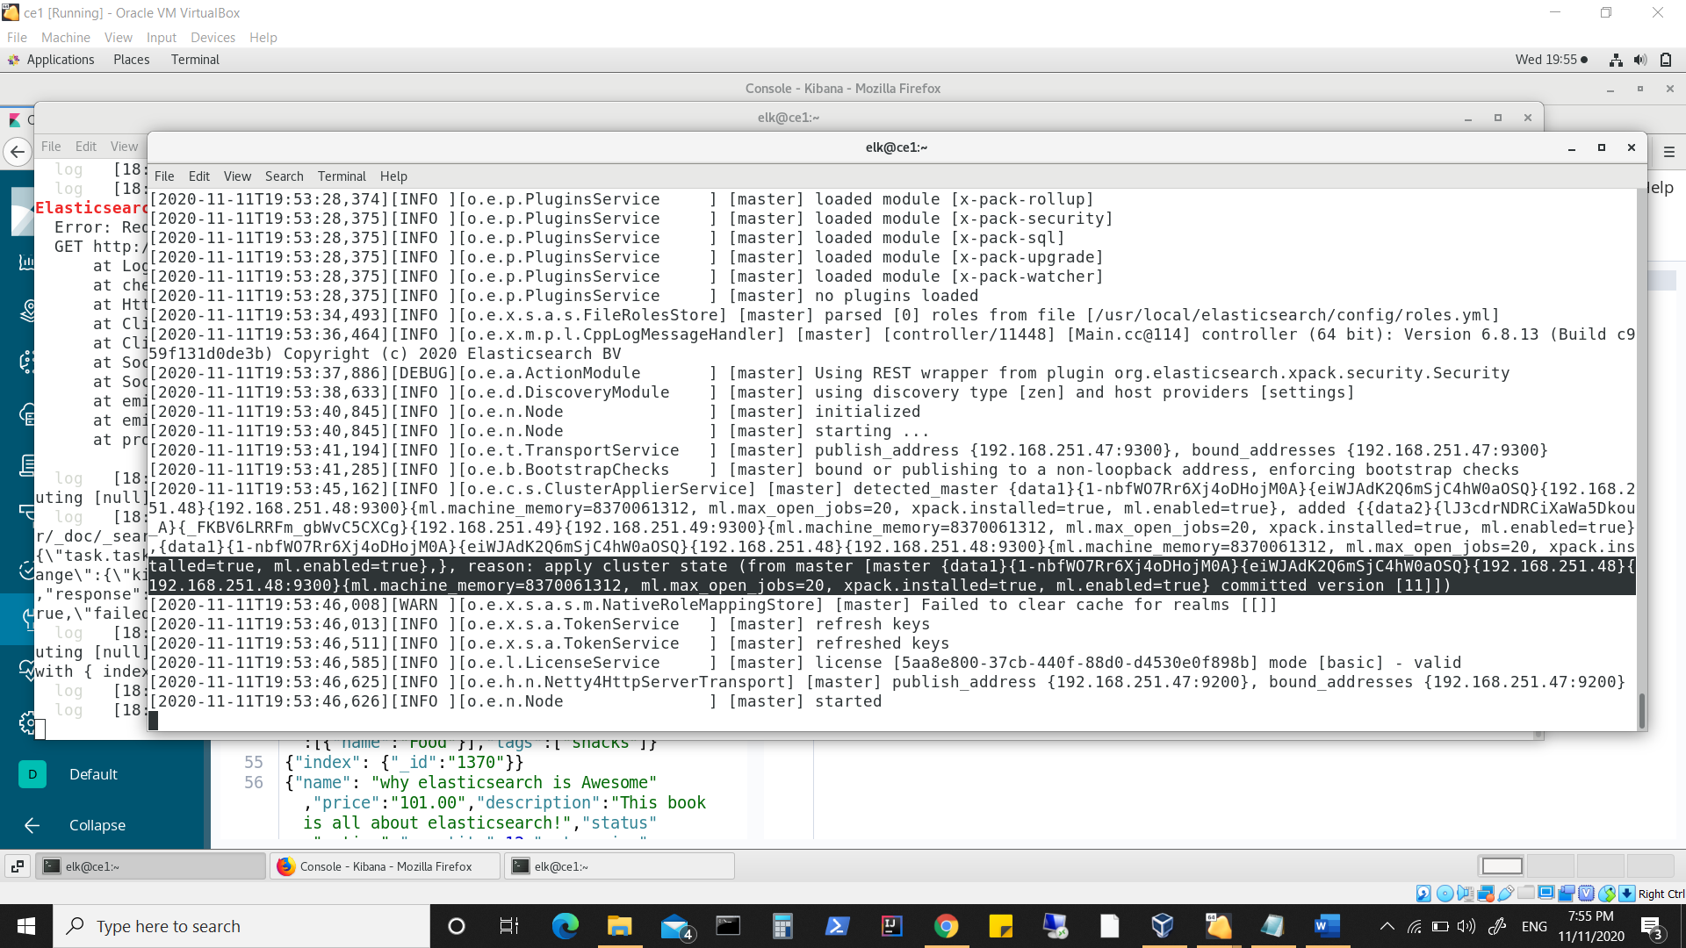

**So all nodes newly started and show same committed version**

**However primary shard is retained with node2(data1)**

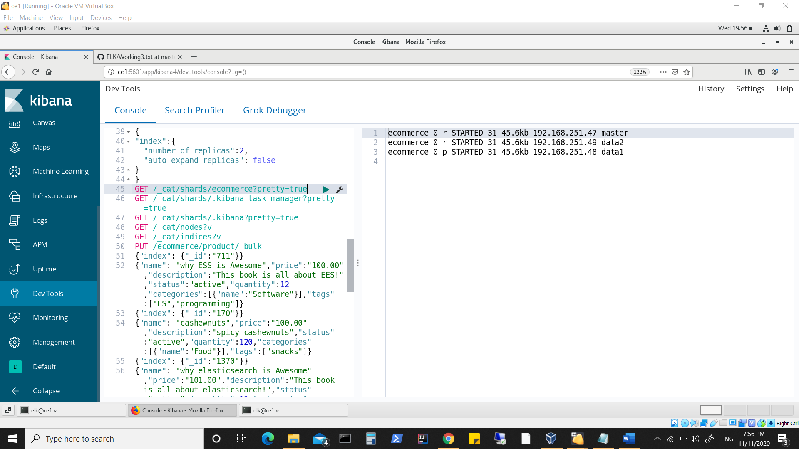

**Which is also the acting master**

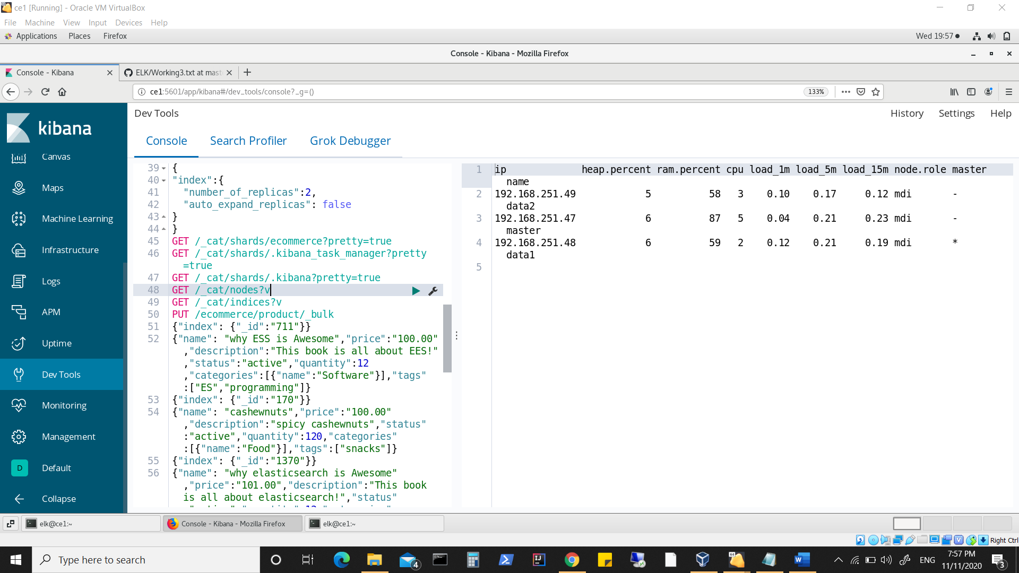

**Master node role assignment happens based on result of election held and quorum decision of majority master eligible nodes.**

**Shard allocation is more of allocation done to nodes rather than election process.**